SCC3 Response Procedure
If you the cavity could not engage the Tuner and Phase lock through EPICS, proceed as follows:
- In ISAC-II Power Supply Room, check if the red LEDs are on for on the Cryo Module Tuner Servo Sysem in the figure below.
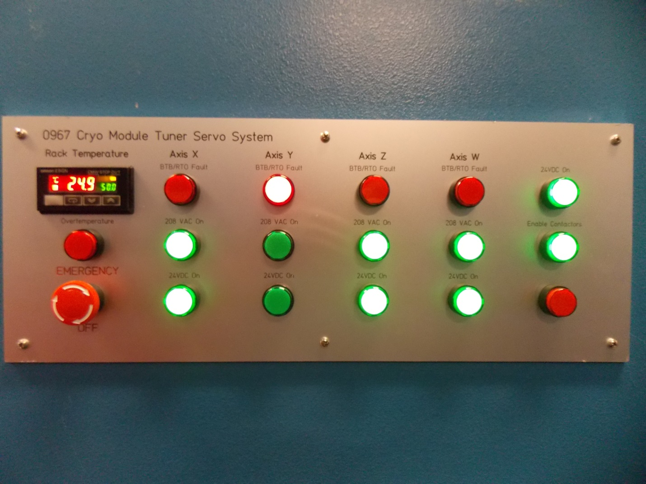
Figure 1 Cryo Module Tuner Servo System
Look up Cavity Tuning control program panel to see if the Amp indicator field shows red.
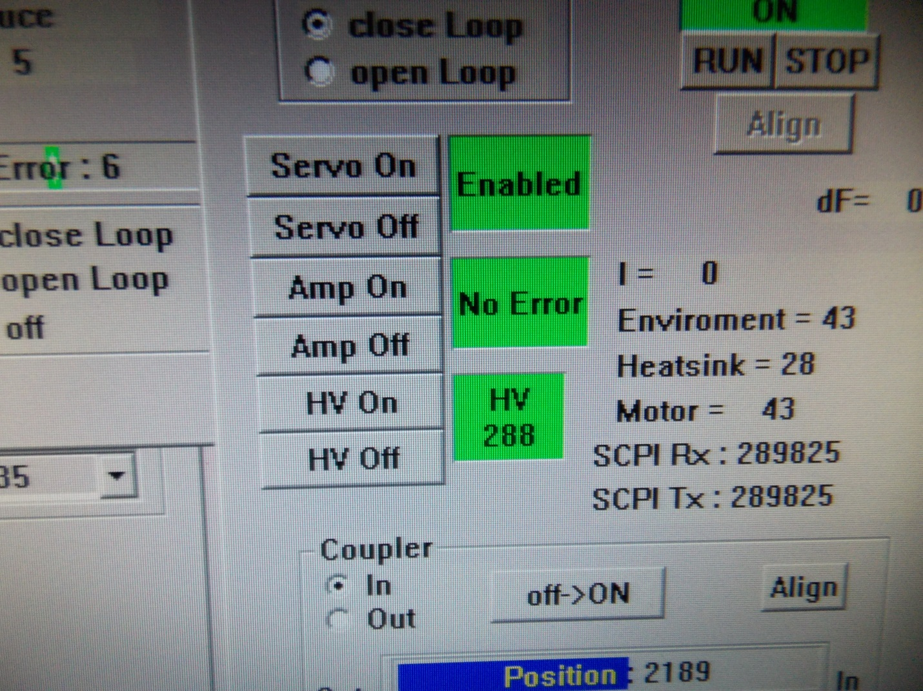
Figure 2 Cavity Control Program Cavity Tuning Panel

- Write down the set-points for Amplitude, Phase Rotator, and Phase for all the cavities on that control console.
- Turn off all the cavities on the console.
- Set the corresponding amplifiers to “Stand By”.
- Shut down the control computer. The console will ask if you want to save before shutting down. Select “Do Not Save”.
- With the console off, power down the VXI mainframe below the screen and wait at least 5 seconds before turning it back on. Then boot up the control console.
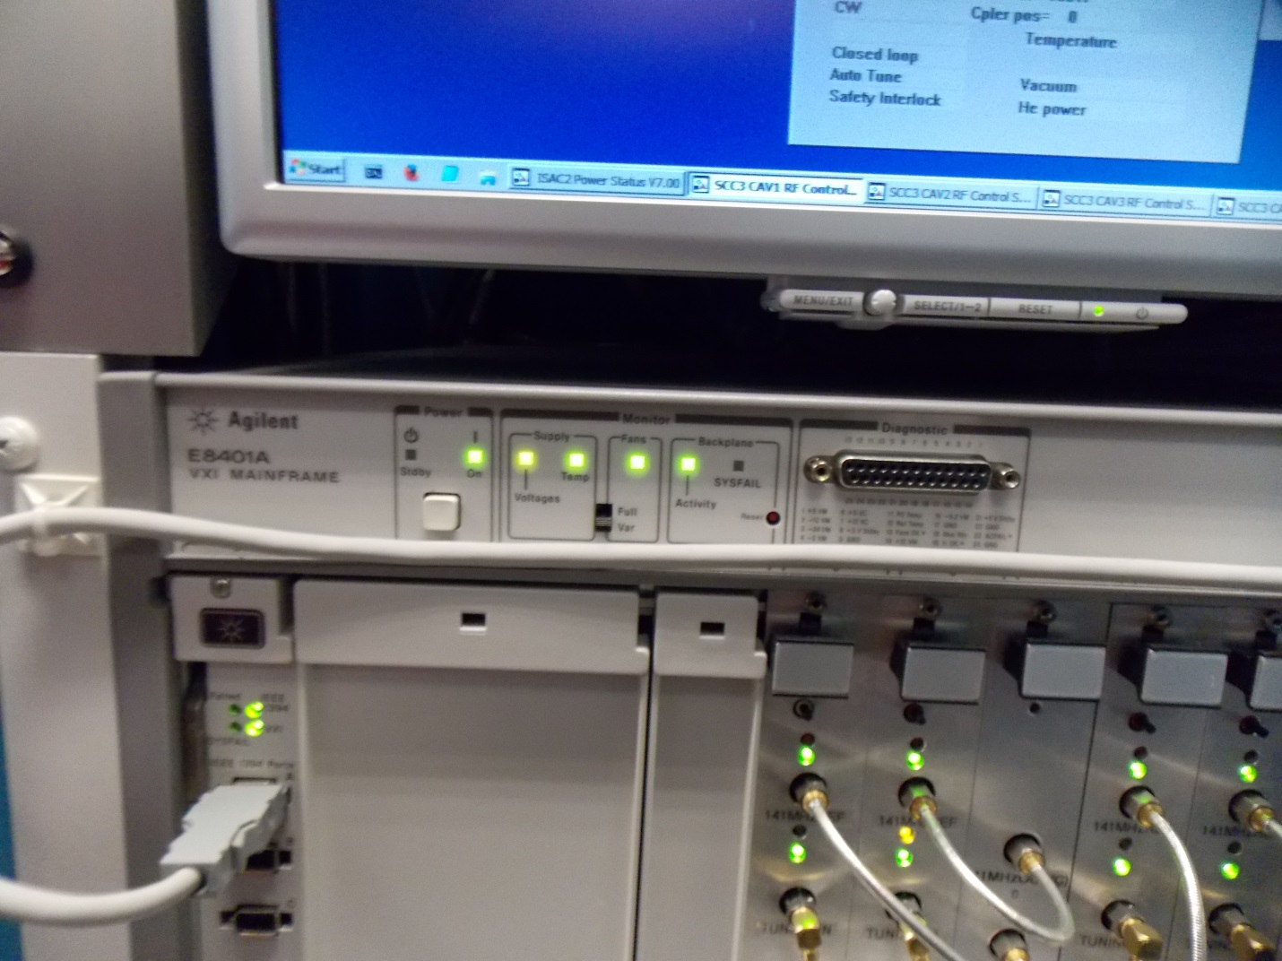
Figure 3 SCRF Control Console VME.
- On the Cryo Module Tuner Servo System panel shown in Figure 2, turn and pull up the “Emergency Off” button to enable the contactors.
- On the control console desktop, right click on the following icons to open the control programs:
AUXX.BAT, SCC3:CAV1, SCC3:CAV2, SCC3:CAV3, SCC3:CAV4.
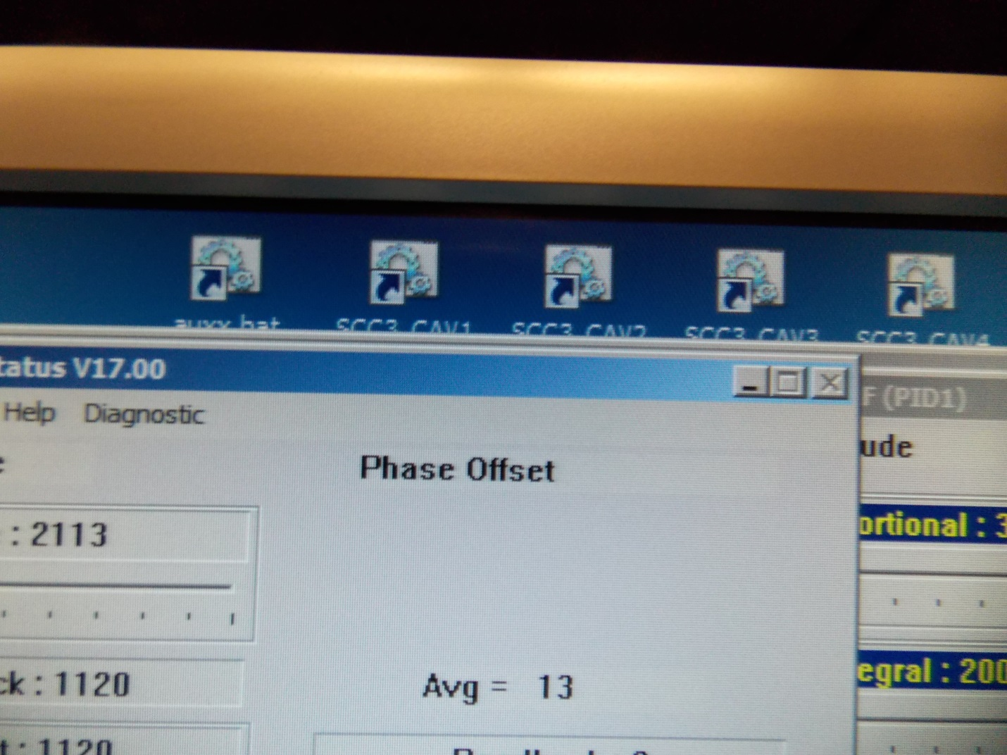
- Enter the set-points noted down in Step 2.
- Turn on the amplifiers by pressing “Operate”.
- Go through all the cavities on that console and enter the set-points
- For each of the affected cavities, click on : Tuner On, Amp On, Servo On.
- Once all of the green LEDs on Cryo Module Tuner Servo System panel lit up, click on Auto-On on each of the affected cavity.

