These instructions describe how to establish a tune through the ISAC-I room-temperature accelerators.

Definitions:
spreadsheet: the "OPTICS ISAC I - september2012.xls" file located in the "Matteo Memorial HEBT" folder on ISAC Documents.

The following assumptions are made:
- Beam is being produced by the OLIS. The source has been optimized by the source expert. Beam is ready on IOS:FC6.
- The operator has had experience and is comfortable tuning LEBT.

Before beginning it is very important to ensure that:
- All CCB's from OLIS to the RFQ are set to 300.
- All steering elements from IOS:YCB6 to the destination are set to zero effect.
- The RFQ is on. All Prebuncher harmonics are off. All MEBT RF is off.
- Beam path is set to HEBT, and the tune has been saved.
- MEBT:CHOPSLIT is out.
- Beamlines not required for the desired path are vacuum-isolated.

OLIS to RFQ
1) Using Rick Baartman's LEBT Beam Dynamics page set all quadrupoles and benders from IOS:Q4 to IRA:Q4 to theoretical values. Be sure to enter the correct "Beam Extraction voltage" on the Beam Dynamics page.
Get the beam extraction voltage from either the MCIS optics page, the OLIS microwave source page, or the OLIS surface source page, depending which source is in use. Note that the OLIS source expert occasionally uses the microwave/surface source bias (IOS:BIAS) when the MCIS source is in use, instead of using MCIS:BIAS0. If you are unsure which Bias is being used, contact the OLIS source expert. Ensure that you have entered the correct extraction voltage using the following formula:

Extraction Voltage = [(2.04 keV/u) x Isotope mass (in amu)]/Charge state of the isotope.

Take a look at IOS quads Q1, Q2, and Q3. Compare their theory values to where the OLIS expert has set them. If they are within 25% of their theory values, leave them where they are and initially try to optimize the OLIS->RFQ tune using only YCB3 to YCB9, and only resort to adjusting Q1, Q2, and Q3 if you have to. If any of these quads have been set significantly off of theory (more than 25% off), go into step 2 knowing that you can try adjusting Q1, Q2, and Q3 along with YCB3 to YCB9 (if this is the case, try to increase transmission while bringing Q1, Q2 and Q3 closer to their theory values).

2) Tune beam from IOS:FC6 to ILT:FC49 for transmission (DON'T fuss over RPM's yet). Expected transmission from FC6 to FC49 is 100% (assuming the OLIS attenuators are out), however tuning for 70-80% transmission is a good start (after this send beam through the RFQ and optimize tune on MEBT:FC5. Once transmission from FC6 to FC5 is good you will likely find that transmission from FC6->FC49 is close to 100%). Benders, steerers and quadrupoles from IOS:Q9 to ILT:FC49 must be left at theory. Try optimizing the transmission using devices from IOS:YCB3 to IOS:YCB9 (including the OLIS dipole). At this stage it is important to define the correct path through the RFQ.
**Important** - Setting ILT optics far from theory may give short-term results (to ILT:FC49) but will likely come back to haunt you (post RFQ). It should be stressed that every issue will be amplified the further along you go. Do not move to "position B" until until you are convinced that the tune to "position A" is ideal. Seek help if you are unsure.
If you are unable to achieve above 70% transmission from IOS:FC6->ILT:FC49 using only IOS:YCB3 to YCB9, you can try adjusting IOS:XCB1->IOS:Q3 as well, but only resort to this if you are convinced that you can't achieve the transmission using optics from YCB3 to YCB9.
While setting up a tune to the front of, and through the RFQ, Marco typically only checks ILT:RPM 37. Once you have decent transmission to ILT:FC49 take a look at RPM37, and ensure that it is centred, has a gaussian shape, and that the horizontal and vertical peaks are roughly the same size. If this RPM is way off, you may have trouble finding beam through the RFQ.

3) Save & document the tune – IOS:FC6 to ILT:FC49 cup readings, the save tune file name, and ILT:RPM 37 should go into the e-log.

Setting the RFQ
1) Open the spreadsheet ("Main & Prague" tab). Enter the following information in the upper left-hand table: "A" (beam mass number) & "Q (FROM OLIS)".

2) Set MEBT:Q1 to MEBT:Q13 to the calculated theoretical values in the "MEBT section" table. Open MEBT:XCOL0 and MEBT:YCOL1. Turn the MEBT Chopper HV plates off (11MHz and 5MHz). All MEBT RF should already be off, the RFQ should already be on.

3) Select the "RFQ" tab in the spreadsheet. Ramp the RFQ amplitude up/down to the calculated Amplitude in the "RFQ TEST" table. Watch the RFQ vacuum as you do this. Moving too quickly may cause a vacuum excursion.

4) Insert MEBT:FC5 and remove all upstream Faraday cups. You should see beam on this Faraday cup. Keep in mind that the FC has a significant negative offset (~500-700pA). If you don't see any beam on MEBT:FC5 revisit the OLIS->FC49 tune, checking RPM's to ensure that they are centered and Gaussian, ensuring that IOS:Q9 to IRA:Q4 optics are at theory, and try to keep IOS:YCB3 to YCB9 as close to theory as you can while maintaining transmission to FC49. If you still can't find beam on MEBT:FC5, go back and ensure that the RFQ amplitude is set for the correct A/Q, and that the OLIS extraction voltage is set properly for the acceptance of the RFQ (2.04 keV/u). If you are still unable to find beam through the RFQ, contact an expert.

5) Optimize transmission through the RFQ. Note that the highest transmission that you expect to see through the RFQ with the Pre-buncher off is 20-25%.
First try touching the optics from IOS:YCB3 to IOS:YCB9, including IOS:MB.
Next try IOS:XCB1 to IOS:Q3. If you make significant gains without losing transmission to ILT:FC49, keep the changes you made, if not leave XCB1->Q3 where they were initially. If you did make changes, try IOS:YCB3->YCB9 again.
Also try the quadrupoles & steerers (small steering adjustments, you want to avoid significant steering here) in front of the RFQ (ILT:XCB49 to IRA:Q4). Optics from IOS:Q9 to ILT:Q48 must be left at theory. If major adjustments are required in the IRA section, re-visit the OLIS tune or contact an expert.

6) Slowly step the RFQ amplitude down until beam disappears. To find where the beam fully disappears, striptool the MEBT:FC5 current. As you get close to having the beam disappear, put in an upstream Faraday cup after each step in the RFQ amplitude. The point where beam disappears is where you don't see a change on the MEBT:FC5 current with beam blocked and not blocked. Once you find the amplitude where beam is lost completely, divide the amplitude by 0.9. Ramp the RFQ amplitude up to this value and leave it.

7) With the Pre-buncher turned off you should expect between 20-25% transmission from ILT:FC49 to MEBT:FC5 (don't forget to factor in the negative offset). If you somehow get >30% through the RFQ there is likely something wrong (the "line" through the RFQ is probably off -- see the last section, point 2. If transmission is ~25% proceed to the next section. If it is >30% you will need to revisit the OLIS => RFQ tune.

8) Save & document the tune – IOS:FC6 to MEBT:FC5 cup readings, the save tune file name, and ILT:RPM 37 should go into the e-log.

9) Ensure that the RFQ RF alarm is enabled.

Setting the Prebuncher
1) Ensure that the Prebuncher all-frequencies phase is set to 0. It will remain there through the whole process of setting up the Prebuncher. The all-frequencies phase is used to fine-tune the Pre-buncher phase to optimize to the acceptance of the RFQ once a tune has been established through to at least MEBT:FC9.

2) Turn on the 11MHz Prebuncher harmonic with an amplitude of ~200. Adjust the phase of the harmonic and then the amplitude. When adjusting the phase initially, scan through a full 360 degrees and select the phase that yields the highest transmission through the RFQ. There will likely be a few different 'peaks' in transmission at different phases. Iterate between the phase and the amplitude until you have maximized transmission to MEBT:FC5. With the 11MHz harmonic on (only) aim for 50% transmission (for "light" beams it may be a bit lower than 50%).
Light beams meaning beams with a low A/Q value. The RFQ can accept A/Q's up to 30.

3) Turn on the 23MHz Prebuncher harmonic with an amplitude of ~100. Adjust the phase of the harmonic and then the amplitude. Iterate between the two and also try the amplitude and phase from the 11MHz harmonic. Maximize transmission to MEBT:FC5. With the 11 and 23MHz harmonics on we expect 70-75% transmission (for "light" beams you may only achieve 60%). For transmissions exceeding 80% be suspicious -- remember, the RFQ amplitude should *not* be adjusted once it is set.

4) Take a grabscreen to save the amplitude and phase that you have set the first 2 pre buncher frequencies to, and note your transmission. Turn on the 35 MHz Prebuncher harmonic with an amplitude of 0. Scan through the phase until you find the largest peak. Next try increasing the amplitude by 10, and then iterate through the phase and amplitude of all 3 frequencies a few times. If this results in an increase in beam, try increasing the 35 MHz amplitude by another 10 and try iterating through the phase and amplitude of all 3 frequencies again. If this results in an increase in transmission again, repeat the process by increasing the 35 MHz amplitude in steps of 10, and compensating by iterating through the phase and amplitude of all three frequencies a few times, until you are no longer making any gains. If you at no point are able to find better transmission with the 35 MHz frequency on than with it off, you may leave it off.
5) Once all 3 pre-buncher harmonics have been optimized, briefly re-visit the OLIS tune. Again try adjusting optics from IOS:YCB3 to IOS:YCB9 while attempting to maximize transmission through to MEBT:FC5. No big changes should be needed here, but you may be able to make some small gains now that the prebuncher has been set. If you make changes here be sure that you haven't decreased transmission to ILT:FC49.
6) Once you are finished setting up the Prebuncher you should have at LEAST 60% transmission, and ideally more like 70-75% transmission, through the RFQ. If you have either over 80% transmission, or less than 60% transmission, contact an expert. This could mean that you may need to revisit the OLIS to RFQ tune or that you have setup the Prebuncher incorrectly.

7) Save & document the tune – IOS:FC6 to MEBT:FC5 cup readings, the save tune file name, and ILT:RPM 37 should go into the e-log.

8) Enable the Prebuncher RF alarms.

Setting the MEBT Bunch Rotator

**Note that the procedure below for setting up the Bunch Rotator below is the procedure used when MEBT:SCOPE1 isn't working properly. If the scope is working, see the 'Setting the Bunch Rotator on the MEBT Scope' procedure (to be written...)**

1) Set the Bunch Rotator phase to 143.1. The amplitude of the Bunch Rotator should scale with A/q. Set the amplitude to the setpoint generated by the spreadsheet ("Bunch rotator" tab). Sometimes, the theoretical value will be too low (below an amplitude threshold the Bunch Rotator will not run stably). In this case simply set the amplitude as low as you can without tripping the device.

2) Load MEBT:Q1 to Q5 from the “MEBT section (Bunch rotator ON)” section of the “Main & Prague” tab of the spreadsheet.

2) Save the tune, and make a note in the e-log that the bunch rotator has been turned on and set.

3) Enable the Bunch Rotator RF alarm.

Setting the MEBT 11MHz Chopper and MEBT optics
1) If a MEBT foil is required, insert a MEBT foil. In the spreadsheet ("Main & Prague" tab) enter the charge after the MEBT foil in the "Q" field. Note: if a MEBT foil is NOT used, "Q" will be the same as "Q (FROM OLIS)". Whether a stripping foil is used or not, and what charge state to choose for after the stripping foil, will be specified by the accelerator expert.
If an accelerator expert is unavailable to specify where (if anywhere) the beam will be stripped, and what charge state will be used, follow these general steps:
i) If the A/Q of the beam from the source is less than or equal to 6, no MEBT stripping will be required. Set the MEBT stripper to a blank position, and enter the same charge state in “Q” on the spreadsheet as you entered in “Q(FROM OLIS)”. Skip steps (ii) to (iv).
ii) If the A/Q of the beam from the source is above 6, MEBT stripping will be required. Look up the last used foil in the E-Log, and insert the next available foil. Set MEBT optics and dipoles for the lowest charge state that gives an A/Q of 6 or below (Be sure to use the values from the “MEBT section (Bunch rotator ON)” section).
iii) Insert MEBT:FC7, increase the MEBT:MB1 setpoint by 10 A. Set the MEBT:MB1 increment to 0.1 A. Set up a striptool to monitor the MEBT:FC7 current, and the MB1 field and current readbacks.
iv) Send beam through to FC7. Tap the MEBT:MB1 current down quickly. This will scan through the various charge states. Identify the different peaks by checking which MB1 current and field each appears at. Use the Main & Prague tab of the spreadsheet to do this. You typically want to choose the charge state that yields the highest transmission in particle nA. To calculate the current of each charge state in pnA, divide the enA reading that it yielded by its charge state (ie FC7 reading 6 nA on a charge state of 6+ is 1 pnA).

2) Enter MEBT:Q1 => MEBT:Q13 theoretical values using the spreadsheet ("Main & Prague" tab, "MEBT section (Bunch rotator ON)” table). Also take note of the theoretical "Dipole" (D1 and D2) settings and set MEBT:MB1 and MB2 ~10A below the theoretical setpoints, ensuring to take the dipoles out of PID loop before changing their current setpoints.

3) Save the tune.

4) Insert MEBT:FC9. Pull out all upstream Faraday cups. **Note** that at this point you may or may not see beam on MEBT:FC9. At no point between steps 5 -> 10 should you worry about the transmission through to FC9.

5) Make sure that both MEBT Chopper HV plates are turned off (MEBT:CHOP:HIGH (11 MHz) and MEBT:CHOP:LOW (5 MHz), both found on the MEBT optics 1 page).

6) Using a previous "good" tune (a finished tune from a previous run that was setup by an accelerator expert), scale the Chopper amplitude linearly with A/q to give you a starting point (note that the A/Q's here are still before any stripping). Turn the MEBT 11MHz Chopper on and set the amplitude to the calculated starting point.

7) Using MEBT:RPM5 as a diagnostic set the Chopper phase such that the main peak is on the right and the two satellite peaks are superimposed on the left (as shown below). Note that here we are only talking about the horizontal beam profile which is shown on the right. The vertical beam profile on the left should always just be one gaussian peak. When you get close, make small (1-2 Deg) changes to fine-tune. Maximize the height of the satellite peak. Make sure that both satellite peaks are included in the smaller peak on the left (do this by temporarily "de-tuning" the Chopper phase by ~5-10 Degrees -- this will cause the smaller peak to split into two distinct peaks). Ensure that none of the satellite peaks are hidden in the main peak.
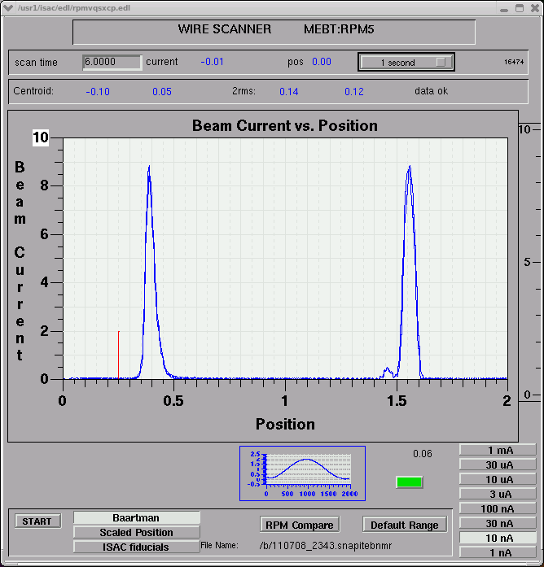
Figure 1 - Expected MEBT:RPM5 profile.

8) Chopper amplitude adjustments will change the separation between the satellite and main peaks. Adjust the amplitude, ensuring complete separation of peaks while keeping them as close together as possible (i.e. their tails should "just" touch). Zoom into the plot by changing the RPM "Beam Current" scale.

9) The X (main peak) and Y profiles on MEBT:RPM5 must be roughly symmetrical (same height and width) with a "2rms" value of ~0.12 (+/- 0.02). To change the profiles try adjusting ILT:Q50-IRA:Q4. MEBT:Q2 and Q3 can also be adjusted (they are very sensitive and should not be changed by more than 1-2A from theory). As a general rule, no other MEBT quadrupoles should be changed from theory. Diverging from theory here will have consequences when tuning the DTL.
The centering of the x and y profiles on RPM5 aren't overly important at this point, and is it actually expected for the x profile to be off of centre until the chopper HV plate is turned on and set.

10) Save the tune.

11) Turn the Chopper 11 MHz High Voltage on at 0V ("MEBT:CHOP:HIGH (11MHz)") and insert MEBT:CHOPSLIT. While monitoring beam on MEBT:FC9 and MEBT:CHOPSLIT (these should be striptooled along with the chopper plate HV) ramp the Chopper HV up (10V increments and "lean" on the keyboard up arrow). As the voltage is ramped up the following will happen: a) the satellite peak will go through the slit and be visible on MEBT:FC9, b) the satellite peak will hit the slit and disappear from MEBT:FC9, c) the main peak will start going through the slit and will be visible on MEBT:FC9, d) the satellite peak will hit the MEBT:CHOPSLIT diagnostic. Maximize the current on MEBT:FC9 and ensure that there is a healthy signal on MEBT:CHOPSLIT. If there isn't, try adjusting the MEBT Chopper amplitude to increase the current on MEBT:CHOPSLIT.

12) Use MEBT:RPM7 (in between the dipoles) as a diagnostic to ensure you are roughly centered horizontally. Use MEBT:MB1 to center beam on MEBT:RPM7. Use MEBT:MB2 to optimize the current on MEBT:FC9. If no MEBT foil is used, the expected transmission for a pure beam from OLIS (no contaminants at the same A/Q) from MEBT:FC5 to MEBT:FC9 is ~ 95% (there will be some losses on the MEBT Chopper Slit) -- remember to take the FC5 negative offset into account. If a MEBT foil is used, or there are contaminants in the beam, contact Marco or Bob to find out what the expected transmission is (taking into account the expected charge state distribution).

13) Save & document the tune – IOS:FC6 to MEBT:FC9 cup readings, the save tune file name, and MEBT:RPM's 5 & 7 should go into the e-log.

14) Enable the Chopper 11MHz RF alarm.

Drifting through the DTL
1) In the spreadsheet set "Energy (MeV/u)" to 0.153 (the energy of the RFQ). Important!

2) Using the "Energy=0.236 MeV/u" table in the "Main & Prague" tab of the spreadsheet, set DTL:Q1 => Q12 to theoretical values. Note that there are 5 different tables for the DTL quads, each for a different DTL energy. Since there is no table for the RFQ energy, use the closest in energy, which is the table labeled 'Energy=0.236 MeV/u'. Using the "HEBT section (FOR PRAGUE MAGNET)" table set HEBT:Q1 => HEBT:Q8 to theoretical values. Ensure that all steerers in the DTL and HEBT are set to zero-effect.

3) Turn off all DTL RF and ensure that the MEBT Rebuncher is off (important!).

4) Optmize transmission through to HEBT:FC5 (the goal is 100% transmission from MEBT:FC9 to HEBT:FC5).

Tips:
a) In a triplet the first and last quadrupoles should be moved ~ together. If one, for example, is set to 100A, the other should be roughly 100A (+/- 5-10A).

b) Looking at DTL:FC3, adjust MEBT:MB1/2, MEBT:YCB7A/B, MEBT:X/YCB3 (small adjustments); Looking at DTL:FC6, adjust DTL:Q1-3; Looking at DTL:FC9, adjust DTL:Q4-6; Looking at DTL:FC12, adjust DTL:Q7-9; Looking at HEBT:FC5, adjust DTL:Q10-12. As you make your way through the DTL, you may need to go back to the MEBT steerers and dipoles listed above and adjust them again slightly.

c) Quadrupoles should end up roughly being set to theory (within 20%).

d) Hysteresis plays a large role when tuning magnet optics. Keep in mind that restoring a setpoint may not bring things back exactly. Try to approach a setpoint from the same direction to minimize hysteresis effects.

e) Don't be afraid to swing quadrupoles around. Use the Fiddle Save/Restore utility as gains are made so that you have restore points.

5) Save & document the tune – IOS:FC6 to HEBT:FC5 cup readings and the save tune file name should go into the e-log.

Find Beam on the Prague Magnet
1) Turn on HEBT1:MB0 and ensure that the device is in "Current" mode. Take note of the theoretical "Hall (PRAGUE)" field ( spreadsheet "Main & Prague" tab) and enter this as the HEBT1:MB0 "Field Setpoint".

2) Adjust the HEBT1:MB0 current to achieve a magnetic field that is close (within 50G) of the theoretical value above. Change the mode from: "Current" to "Field" (i.e. press the button). A PID loop will move the magnet to the theoretical field setpoint.

3) Ensure that HEBT1:HARP0 and HEBT1:FC0 are in, and remove all upstream Faraday cups. You should see a beam profile on the harp. If you don't, try adjusting HEBT:X/YCB5 (these steerers should be set to zero effect once the energy is set but can be used to increase beam on the harp while you are setting up the energy. Keep an eye on the top and bottom plate skimmers (found on the HARP0 page) while you adjust HEBT:YCB0. The top and bottom plate should read approximately the same amount of beam). If no MEBT foil is being used the measured energy at the Prague should be ~153keV/u. If a foil IS used, there will be some energy loss through the foil and you will likely measure an energy of ~ 152.5keV/u at the Prague harp.
**For information on measuring energies at the Prague harp, see the 'DRAGON Small Energy Change' document.**

4) Save & document the tune – the save tune file name, the measured energy, and a snapshot of the Prague harp should go into the e-log.

Setting the MEBT Re-Buncher
1) Take note of the beam position on the Prague magnet. After setting the MEBT Re-Buncher the shape will change but not the position.

2) In the "Re-Buncher" tab of the spreadsheet take note of the theoretical Re-Buncher amplitude. Turn on the MEBT Re-Buncher with an amplitude of ~ 200. Adjust the phase such that the profile on the Prague Harp does not move. There will be two phases where this condition is satisfied (180 Deg apart). Choose the phase that causes the profile to move to the left when the phase is lowered. Set the Re-Buncher amplitude to the theoretical value noted above. Fine-tune the phase to maintain the position noted in 1.
Note: The expected Harp profile is NOT sharp and will likely span ~ 11-12 wires (see below).
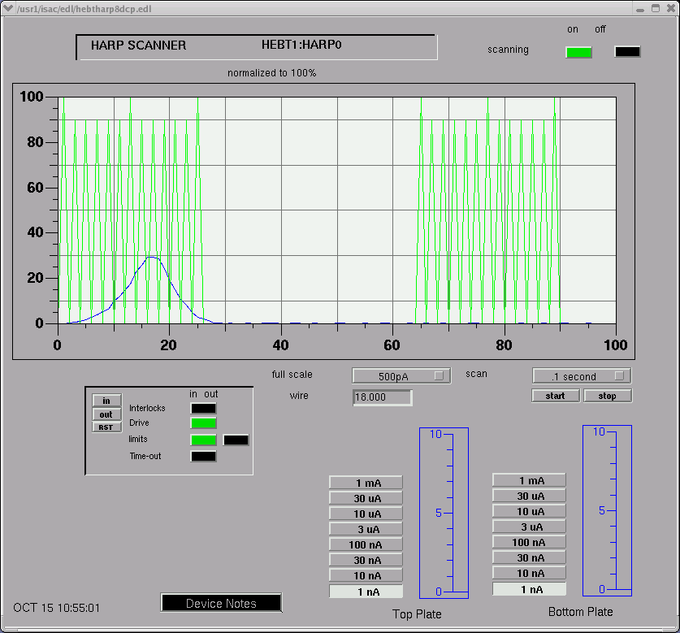
Figure 2 - Expected HEBT1:HARP0 profile for Rebuncher on.

3) Using the DTL tuning tips above, re-optimize the transmission through the DTL (we expect ~100% at this stage).

4) Save & document the tune – the save tune file name, the measured energy, and a snapshot of the Prague harp should go into the e-log.

5) Enable the Re-buncher RF alarm.

Setting a Beam Energy of 0.238MeV/u (DTL:TANK1 on)
1) Turn on DTL:TANK1 with an amplitude of roughly 200.

2) In the spreadsheet change the "Energy (MeV/u)" field to 0.238 (the theoretical energy with TANK1 on). Set HEBT:Q1 => Q8 to theory, again using the values from the 'HEBT section (for Prague magnet)' table. Take note of the new "Hall (PRAGUE)" theoretical field. Change the HEBT1:MB0 mode to "Current". Change the field setpoint to the destination theoretical field setpoint, but be sure to leave the magnet in “Current” mode.

3) You likely will have lost beam on the Harp. Scan the TANK1 phase and find beam on the Harp.

4) Adjust the TANK1 phase such that the beam moves to the left (the accelerating / higher energy direction). When the profile hits the left side of the harp, increase the HEBT1:MB0 current. This will cause the profile to move to the right. When the profile hits the right side of the harp, adjust the TANK1 phase to move the profile back to the left. Repeat this step until phase adjustments no longer accelerate the beam. You may lose transmission through the DTL during this step or during step 5. If the profile on the harp becomes too small to continue, see step 6 (you will need to come back to steps 4/5 until you reach the desired energy).

5) Adjust the TANK1 amplitude such that the beam moves to the left (the accelerating / higher energy direction). When the profile hits the left side of the harp, increase the HEBT1:MB0 current. This will cause the profile to move to the right. When the profile hits the right side of the harp, increase the TANK1 amplitude to move the profile back to the left. Repeat this step, checking periodically that the phase is still set for maximum acceleration until the HEBT1:MB0 hall probe readback matches the theoretical field setpoint. Set HEBT1:MB0 to "Field" Mode and fine-tune the TANK1 phase/amplitude. The goal is to achieve an energy of 0.238MeV/u using the minimum possible amplitude (if acceleration can be achieved using the phase, reduce the amplitude). It's a bit of an art, but try to adjust the two to give a symmetric beam (minimize the low/high-energy tails). The profile should be centered two wires to the right of the fiducial, as shown below.
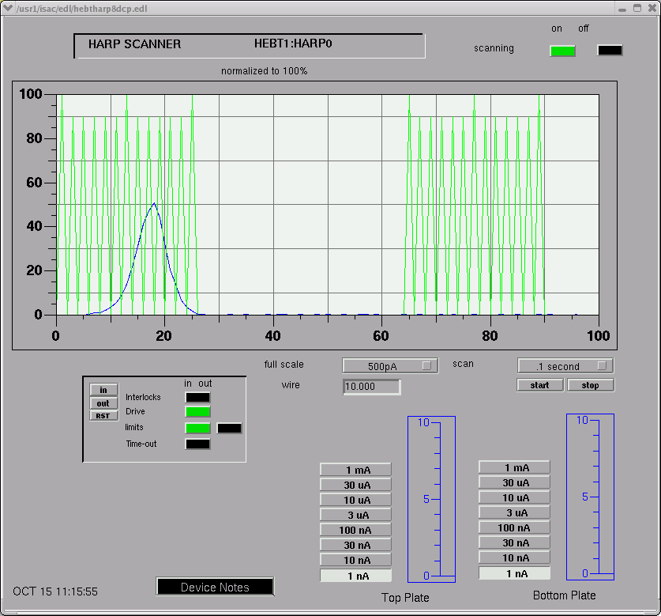
Figure 3 - Expected HEBT1:HARP0 profile for Tank 1 on.

6) Transmission through the DTL will be low. The energy of the beam has been changed but the optics have not been optimized. Using the same procedures as above (Drifting through the DTL), optimize DTL:Q1-12 in order to achieve ~100% transmission from MEBT:FC9 to HEBT:FC5. Use the setpoints in the spreadsheet "Energy=0.236 MeV/u" table as a guide.

7) Check the Prague harp profile and adjust the phase/amplitude as necessary to maintain centering (two wires to the right of the fiducial) and shape.
Note: The expected Harp profile is NOT sharp and will likely span ~ 7-8 wires (as shown above).

8) Save & document the tune – IOS:FC6 to HEBT:FC5 cup readings, the save tune file name, the measured beam energy, and a snapshot of the beam profile on the Prague harp should go into the e-log.

9) Enable the DTL Tank 1 RF alarm.

Setting a Beam Energy of 0.254MeV/u (DTL:BUNCH1 on)
1) Turn on DTL:BUNCH1 with an amplitude of roughly 200.

2) In the spreadsheet change the "Energy (MeV/u)" field to 0.254 (the theoretical energy with BUNCH1 on). Set HEBT:Q1 => Q8 to theory again using the values from the 'HEBT section (for Prague magnet)' table. Take note of the new "Hall (PRAGUE)" theoretical field. Change the HEBT1:MB0 mode to "Current" (important). Change the field setpoint to the destination theoretical field setpoint. Do NOT change the HEBT1:MB0 mode yet!

3) You likely will have lost beam on the Harp. Scan the BUNCH1 phase and find beam on the Harp. Two phases will result in beam on the harp (180 Deg apart). Choose the phase where lowering the setpoint causes the beam to move to the left. Fine-tune the phase to center it on the harp (with the buncher on/off the beam profile does not move on the harp). Take note of this phase setpoint. Subtract 45 Deg from it and set the phase to this new value (it will accelerate the beam). From this point on the phase of this cavity should not be touched! Adjust the HEBT1:MB0 current (increase it) to get beam back on the harp.

4) Adjust the BUNCH1 amplitude such that the beam moves to the left (the accelerating or higher energy direction). When the profile hits the left side of the harp, increase the HEBT1:MB0 current. This will cause the profile to move to the right. When the profile hits the right side of the harp, increase the BUNCH1 amplitude to move the profile back to the left. Repeat this until the HEBT1:MB0 hall probe readback matches the theoretical field setpoint. Set HEBT1:MB0 to "Field" Mode and fine-tune the amplitude to center the profile. The goal is to achieve an energy of 0.254MeV/u. The profile should be centered two wires to the right of the fiducial (see below).
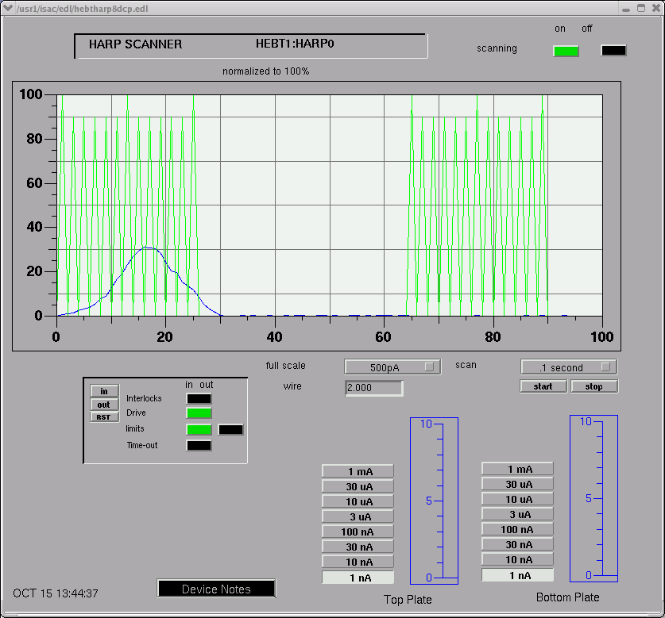
Figure 4 - Expected HEBT1:HARP0 profile for Buncher 1 on.

5) Transmission through the DTL will be low. The energy of the beam has been changed but the optics have not been optimized. Using the same procedures as above (Drifting through the DTL), optimize DTL:Q1-12 in order to achieve ~100% transmission from MEBT:FC9 to HEBT:FC5.

6) Check the Prague harp profile and adjust the amplitude (not the phase) as necessary to maintain centering (two wires to the right of the fiducial).
Note: The expected Harp profile is NOT sharp and will likely span ~ 7-8 wires (see above).

7) Save & document the tune – IOS:FC6 to HEBT:FC5 cup readings, the save tune file name, the measured beam energy, and a snapshot of the beam profile on the Prague harp should go into the e-log.

8) Enable the DTL Buncher 1 RF alarm.

Setting the Remainder of the DTL (up to 1.5MeV/u)
Repeat the steps above (setting TANK1 and BUNCH1) for all remaining cavities. Expected transmission through the DTL with all cavities on is 90-95%. The following are the maximum energies for each RF Cavity (substitute these numbers in the optics spreadsheet when necessary) as well as the expected profile width for each cavity. Enable all relevant cavity RF alarms as they are tuned.

Cavity | Energy (MeV/u) | Approximate Expected  Prague Harp  Profile Width (wires)
RFQ | 0.153 | 7-8
Re-Buncher | 0.153 | 11-12
TANK1 | 0.238 | 7-8
BUNCHER1 | 0.254 | 7-8
TANK2 | 0.439 | 7-8
BUNCHER2 | 0.461 | 6-7
TANK3 | 0.781 | 6-7
BUNCHER3 | 0.803 | 6-7
TANK4 | 1.149 | 5-6
TANK5 | 1.530 | 3-4
Table 1 -- Maximum beam energy expected for each RF cavity.

**See the end of this document for snapshots of the expected beam profile for Tank2 – Tank 5 on.**

Note: The Prague magnet must be turned off (in current mode!) when not in use. It has been specified to run continuously at 100A, but overheats at 150A in ~20minutes risking damage.

Delivering Beam to HEBT / ISAC-II
1) HEBT:Q6-Q8 are presently set to deliver beam to the Prague Magnet. For delivery to DRAGON select the "Dragon" tab and load the theoretical quadrupole and dipole values for HEBT:Q6-HEBT2:Q8. Note that "miniquad" refers to HEBT2:Q1.

2) Check that all steerers from HEBT:X/YCB0 onwards are set to zero effect.

3) Using HEBT steerers and the HEBT2 dipoles, optimize the current to HEBT2:FC4. You may not get 100% transmission. At this stage this is ok. Focusing will likely need to be adjusted.

4) Adjust DTL:Q10-12 while monitoring the beam profiles on HEBT:RPM5 and HEBT2:RPM4. It may take many iterations, but the goal is to have symmetric beams (same width and height in X and Y) at both monitors.

5) Re-check the transmission to HEBT2:FC4. Fine-tune the HEBT steering elements and dipoles to maximize the transmission. The goal from HEBT:FC5 to HEB2:FC4 is 100%. If you're not able to optimize transmission using HEBT elements, try touching the MEBT dipoles and MEBT:YCB7A/B. The ISAC-I RF Global Phase may also improve transmission. Other useful knobs (small changes only): Pre-Buncher all-frequencies phase (ISAC1:PBN:PSET), MEBT Re-Buncher phase, Tank1 phase, Buncher1 phase. If RF phases are touched, be sure to check the energy at the Prague Harp when you are finished. It may change slightly and require a touch-up using the final RF cavity.

6) Save & document the tune – IOS:FC6 to HEBT2:FC4 (or other final Faraday cup if not delivering to DRAGON) cup readings, the save tune file name, the measured beam energy, and any additional comments you have on setting up the tune should all go in the e-log.

7) Ensure ISAC-I RF alarms are enabled as required.

DRAGON Tuning Notes
1) The DRAGON CCD should not be used to optimize the beam shape (it should only be used to optimize the position). If the beam is not circular on the CCD one must go back and tune for transmission. Special care must be taken to optimize the profiles at HEBT:RPM5 and HEBT2:RPM4 (using the final DTL quadrupoles). We must not change the HEBT2 qudrupoles significantly from theoretical settings unless approved by the high-energy expert. Non-standard tunes are not desired because they are not reproducible.
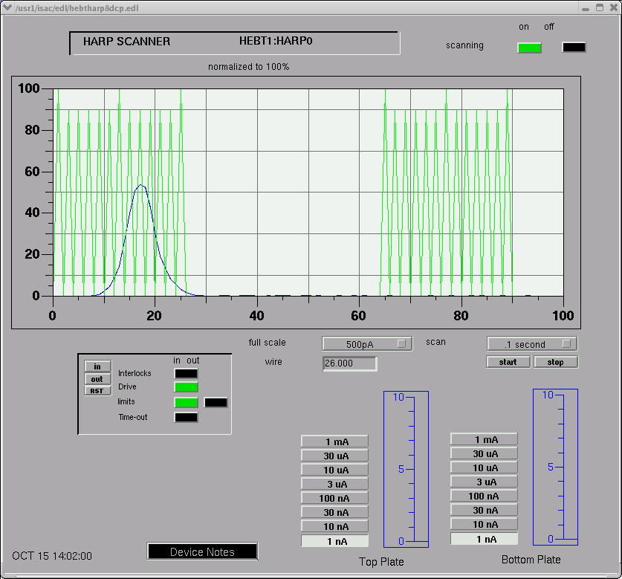
Figure 5 - Expected HEBT1:HARP0 profile for Tank 2 on.

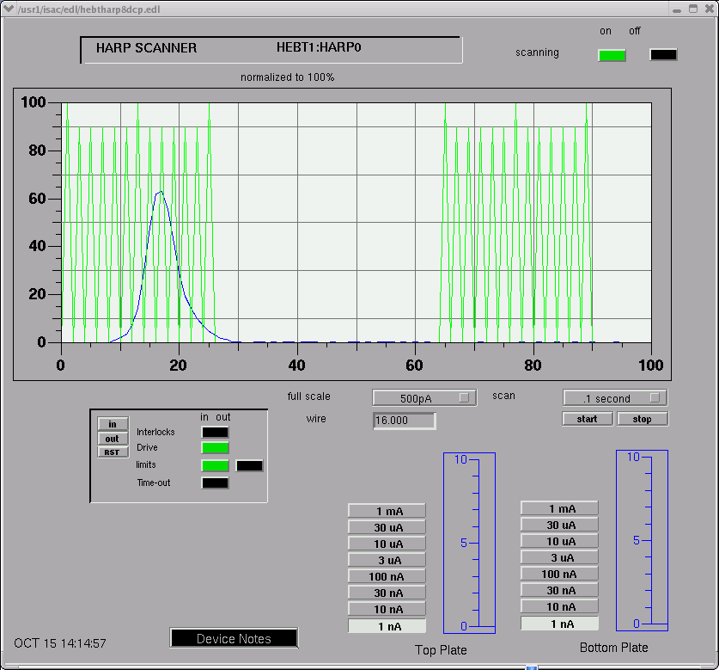
Figure 6 - Expected HEBT1:HARP0 profile for Buncher 2 on.
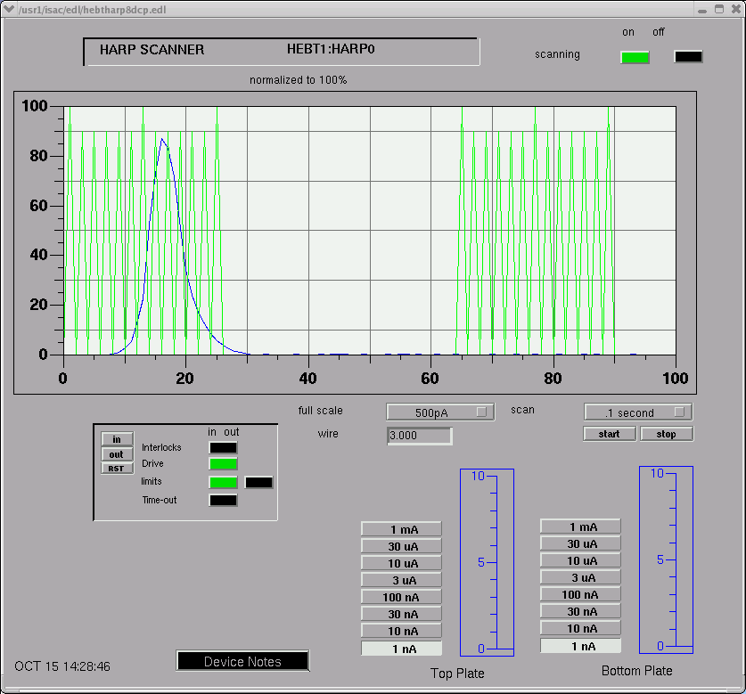
Figure 7 - Expected HEBT1:HARP0 profile for Tank 3 on.
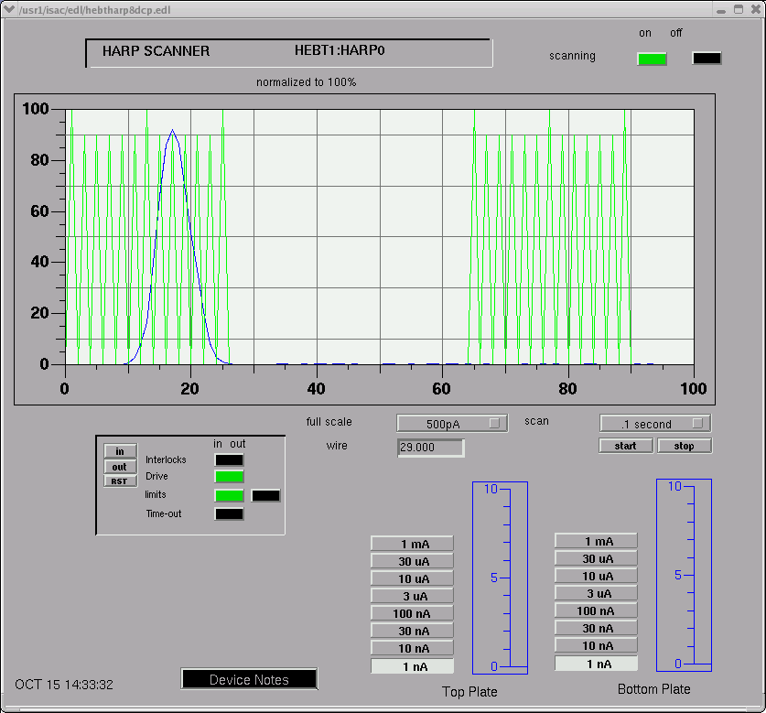
Figure 8 - Expected HEBT1:HARP0 profile for Buncher 3 on.
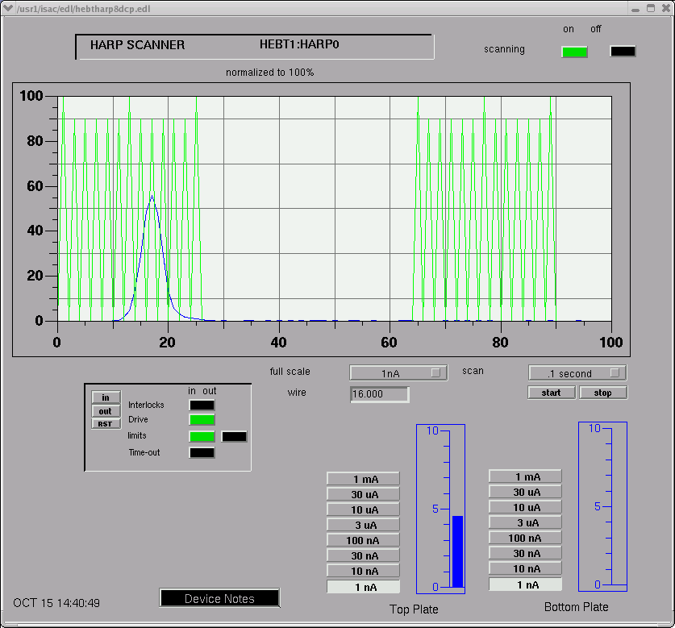
Figure 9 - Expected HEBT1:HARP0 profile for Tank 4 on.
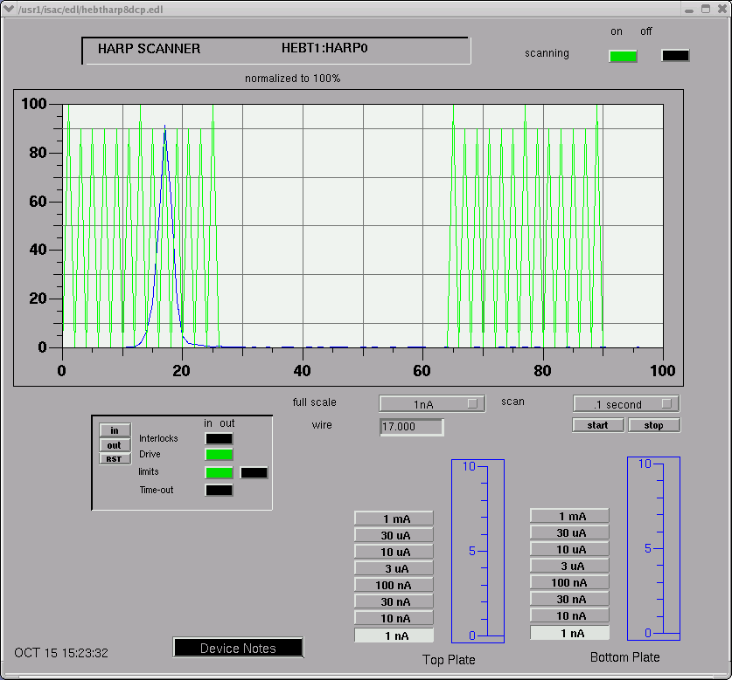
Figure 10 - Expected HEBT1:HARP0 profile for Tank 5 on.

