Polarizer Test, Oct 1-3, 2013

We will be polarizing a ³¹Mg⁺ ion beam directly, without the complications of neutralizer and reionizer cells.

The goal of the test is to polarize ³¹Mg⁺, transport it to the BNQR facility and optimize the observed beta decay asymmetry. The Polarizer has been modified from its usual alkali-beam running condition as follows:

- The Na cell and its thermocouples, the He cell and deflector plate ILE2:DEF15C have been removed.

- A drift tube 2.1 m in length has been placed along the Polarizer axis.

- The deceleration electrodes at the entrance to the Polarizer are matched by a set of acceleration electrodes at the exit.

- The laser is frequency-doubled into the ultraviolet (280 nm).

- Large rectangular magnetic field (~10 gauss) coils downstream of the Polarizer will be turned on manually.

The modifications enable us to tune the energy of a 20.00 keV ³¹Mg⁺ beam using the usual deceleration electrodes control ILE2:BIAS15, to maintain that energy over the drift tube length while the beam is optically pumped, and to accelerate the beam back to its original energy at the exit of the Polarizer. The drift tube is divided into 5 segments that allow us to polarize all the beam ions. A bias of 98 V applied by ILE2:BIASTUBE is used to make sure all the beam is polarized.

Tuning procedure:

The usual methods of ion beam tuning are to be used. Before beginning, ensure that the following are OFF:

ILE2:SOL15B
ILE2:DEF15C

And set the following values:

ILE2BIAS15 = 100 V
ILE2:BIASTUBE = 98 V.
ILE2:SOL15A = 4 amps (octagonal coils 1 - 8, see attached Fig. 1)
Rectangular coils (11 - 13) = 170 amps (manually controlled power supplies near BNQR will be operated by experimenters)

A good tune will have ~100% transmission through the Polarizer. The aperture in the (upstream) deceleration electrode is 16 mm in diameter. The acceleration electrode has an aperture diameter of 10 mm. There are no other restrictions in the Polarizer.

Note that the 10 gauss fields generated by the rectangular coils tend to deflect the beam vertically. The last time this type of tune was used was April 2009 during a 11Be+ run, which used a similar setup.

Fig.1:

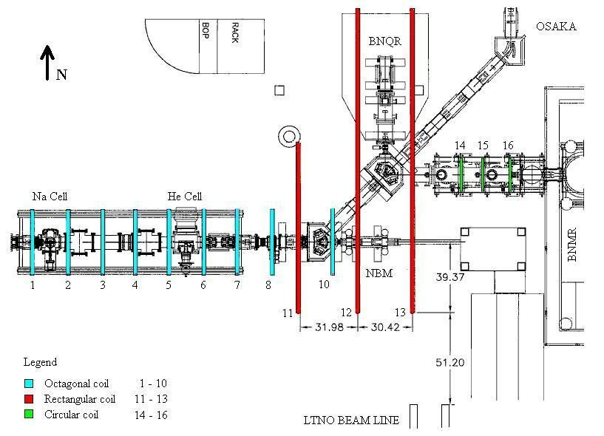

Phil Levy
Oct 1, 2013

