OLIS MCIS RF power supply reset information

When the OLIS MCIS RF receives a “TWT thermal fault” error message, it is displayed on the MCIS RF EPICS page in yellow font as shown in the picture below (You will also notice that the output power has gone to 0):

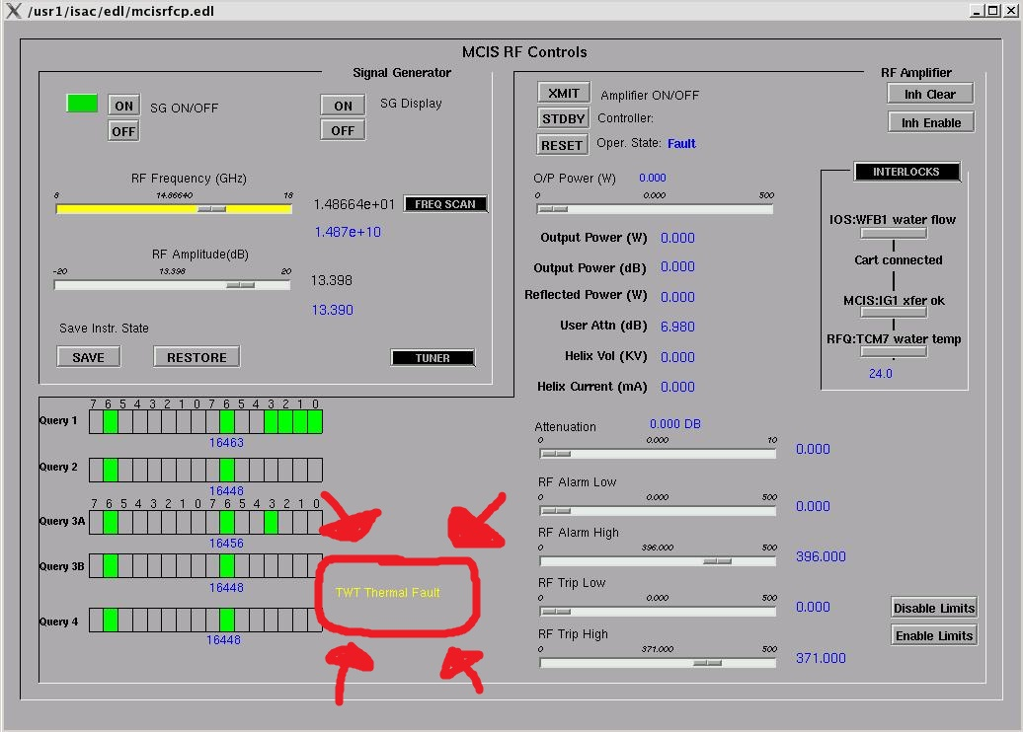

If this situation occurs, we need to reset the MCIS RF power supply which is located on top of the OLIS cage, on the NW side. The MCIS RF power supply is located on the bottom right. See the picture below:

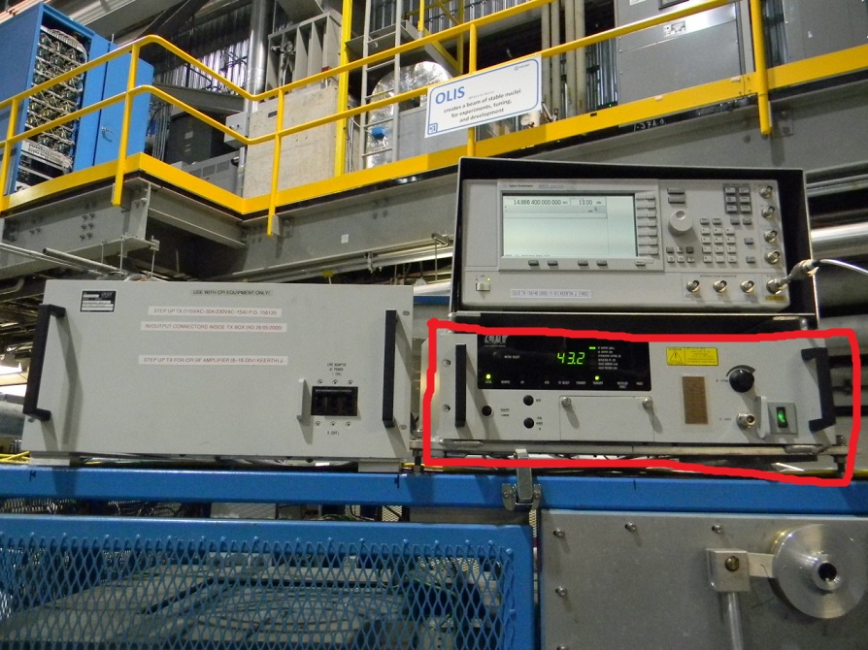
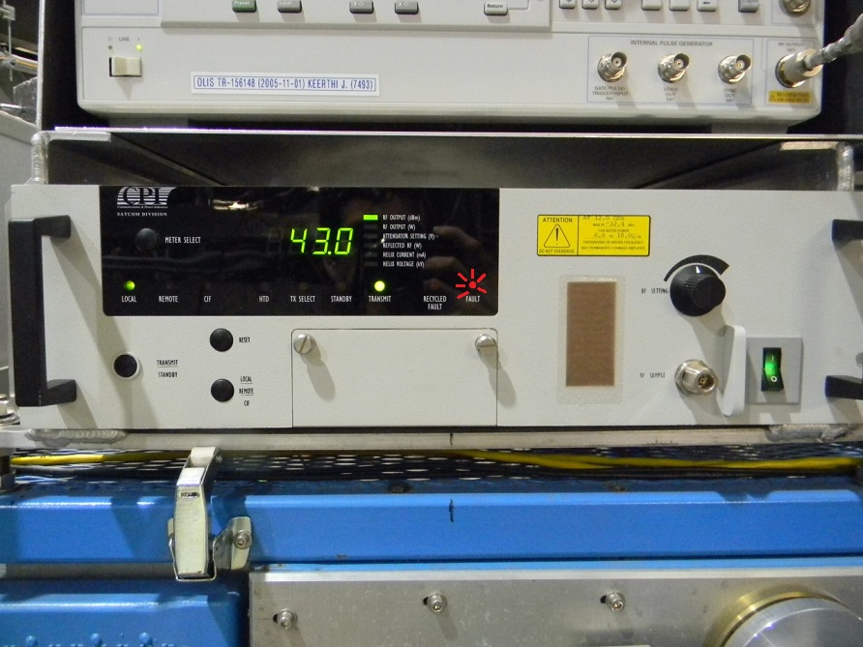
When this error occurs, the red light above “FAULT” will be blinking. (drawn in to the above picture). The reset procedure is as follows:
1. The “RESET” button (black colour) needs to be pressed once.
2. After that the yellow light for “STANDBY” should come ON.
3. Next press the “TRANSMIT/STANBY” button (black colour).
4. The green light above “TRANSMIT” should come ON. You should notice that the output power readout is no longer 0.

The buttons are displayed in the picture below:
