Title: How to Reset the OLIS Separator Stability Power Supply

 | Name | Signature | Date
Written by: | D. Gallop |  | Mar. 26, 2010

Background

The OLIS separator magnet has a field stabilizing system. It is always on. It is an automatic background process, requiring no operator intervention. It works by applying a small correction current to the magnet coils based on Hall probe readings and a standard PID loop algorithm. This correction is made using an accurate Kepco bench power supply operating between 0A and 4A. Any change to the magnet setpoint, whether user-adjusted or computer controlled, will cause the system to pause. The primary motivation for implementing this system was in aid of accurate selection of higher charge state beams from the Supernanogan ion source. It also works well for any ion source at OLIS.

IOS Events and Response: OLIS Separator Stability Reset Button

Occasionally the separator magnet power supply will be tripped, perhaps due to an IOC reboot, a power bump or any other cause. If left in an off state for a prolonged time, operator intervention will be required to reset a limiting condition in the Kepco power supply. I have provided a button for this purpose on one ISAC console (grolsch). The opposite correction (usually down 2A) to the Philtek separator power supply is also required if beam is already on and the field set. Fine tweaking of the field afterwards is inevitably required. A limiting condition is likely present if a Stripchart of the magnetic field shows wandering, notably above a baseline. It can be confirmed by starting an OLIS Stability Status session on the same console.

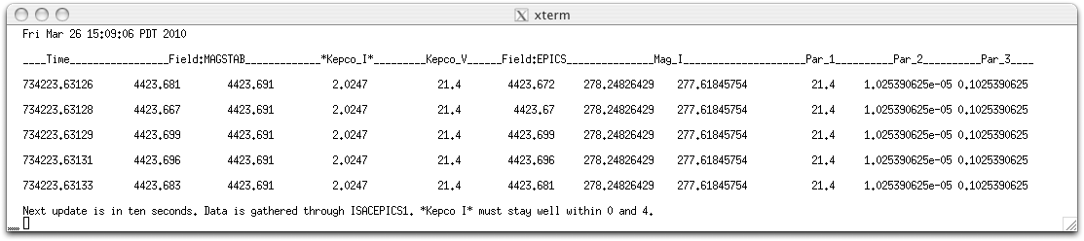
Figure 1: A normal state OLIS Stability Status window with Kepco at middle of its range

