Title: Monitoring actinide target conditioning at ISAC teststand from the ISAC control room

 | Name | Signature | Date
Written by: | F. Ames |  | 11/02/09
Reviewed by: | A Reviewer
Approved by: | An Approver

Summary:

This document describes actions to be taken by the ISAC operators during the conditioning of the actinide target at the ISAC teststand in November 2009

History of Revisions:

Rev # | Date | Description of Changes | Initials
1 | 03-Dec-2004 | First Issue. | A.H.
2
3
4

Background information

The actinide target scheduled to be running on-line in December 2009 will be first installed and conditioned at the ISAC ion source teststand located in the Service Annex Extension (across from MCR first aid room).
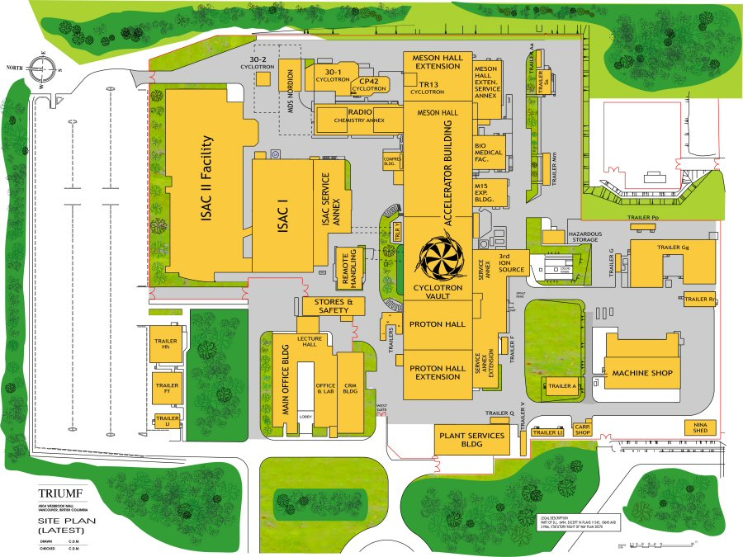
During this time it will be pumped down, the heater currents will be raised and the FEBIAD ion source will be started. Set-up and operation will be performed by the target specialists. The target and source will be kept running for several days. Although, the system is protected by interlocks safety requires constant monitoring. Therefore an alarm handler and access to the teststand controls system has been installed in the ISAC controls room.

Actions to be taken by the operators

At the beginning of each shift the operators should make sure the teststand alarm handler is running on tooheys.
To start the alarm handler:
open a xterm window on tooheys
go to directory bin (type “cd bin” and press <enter>)
run: start_ISACT_alh.sh (type “start_ISACT_alh.sh” and press <enter>)

This will start the alarm handler and open the ISAC teststand main menu

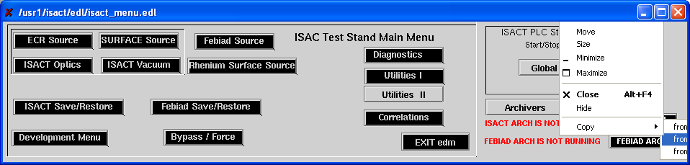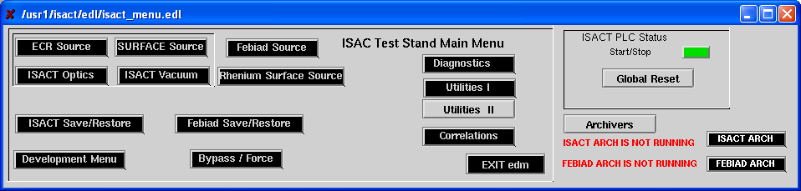

Figure 1. ISAC teststand main menu

Actions to be taken in case of an alarm

The alarm handler will alarm in case the vacuum in the teststand ion source box becomes bad, indicating a malfunctioning of the target. The alarm handler will directly call the pager of Friedhelm Ames (604-641-0439). In case there is no response within 5 minutes the operators should call Friedhelm Ames directly (home 604-221-4129). If he can not be reached they should try to contact Pierre Bricault (pager 604-645-0113; home 604-325-5045; cell 778-990-0703). If both can not be reached the operators should open the menu point for the “FEBIAD Source” and switch off all power supplies if they have not been switched off by the interlock system. Do not ramp down heaters: just turn them off at whatever current they are. After this from the main menu they should open the vacuum controls page “ISACT vacuum” close the valves TPSGV4, TSGRV1A and TSGRV1B and shut off the turbo pumps TSGTP1A and TSGTP1B.

This brings the system into a safe state and a message should be left for Friedhelm Ames and Pierre Bricault.

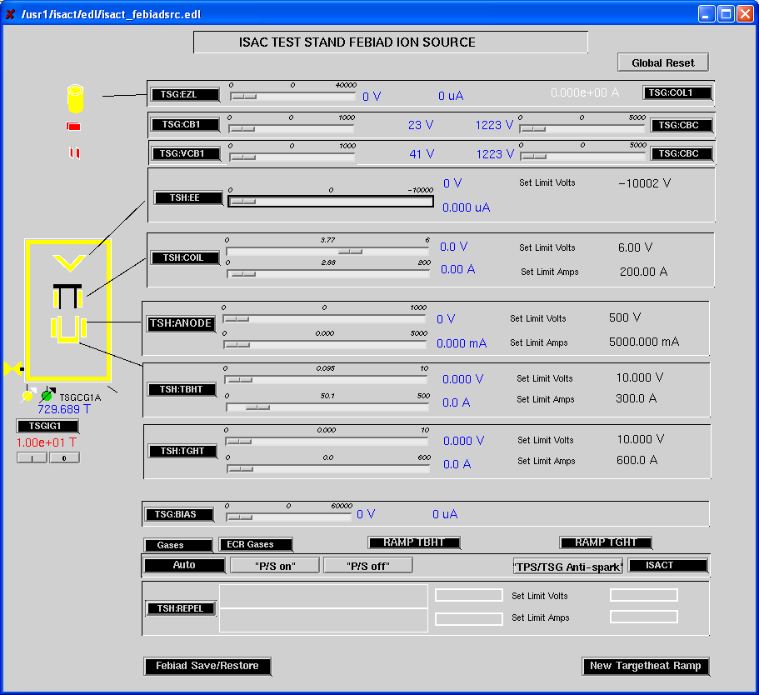

Figure 2. FEBIAD source controls window

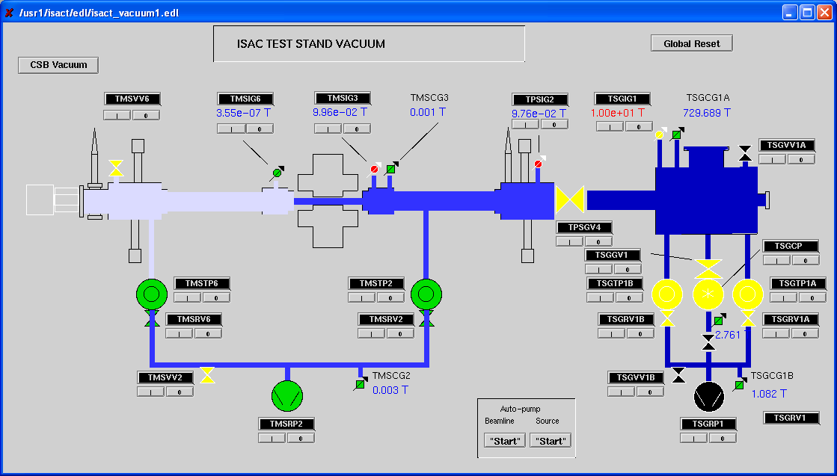

Figure 3. ISAC ion source teststand vacuum controls window

ISAC Operations sign-off when the document has been read:

Name | Initials | Date
Tiffany Angus
Jonathan Aoki
Eric Lee
Nina He
Ed Parton
Roxana Ralea
Scott Kajioka
Robert Shanks
Rene Tanaja | TRIUMF ISAC Operations Note  Document ID: TRI-ION-04-09  Issue No: 1  Revision No: 1  Date Issued: Nov. 2, 2009 Author: F.Ames
John Wong

2TRIUMF ISAC Operations Note

Document ID: TRI-ION-04-09
Issue No: 1
Revision No: 1
Date Issued: Nov. 2, 2009 Author: F.Ames

