ISAC-II SC cavity manual start from EPICS interface
V. Zvyagintsev
30/07/2013
ISAC-II SC Cavity manul start from EPICS interface (when auto-on fails);
‘Vladimir’s Method,’ 2013:

- RF CONTROL
  - Leave amplitude (‘Voltage’) at setpoint.
  - Open Loop Drive ~500.
  - CW mode.
  - RF on.
  - Check amplitude readback: it should be at least several hundreds.
    - If there is no amplitude readback, turn off cavity and turn on again (RF on) until amplitude readback attained.
    - If i. doesn’t work, switch cavity to pulse regime, wait ~5 min. Switch cavity back to CW looking for amplitude readback. Make several attempts if necessary.

- COUPLER LOOP
  - Check Forward Power (Pfwd): it should be less than 200W.
    - If Pfwd exceeds 200W, reduce Open Loop Drive to reduce Pfwd below 200W.

- RF CONTROL
  - Lock amplitude.
  - If amplitude readback matches setpoint, ‘AUTO-ON.’
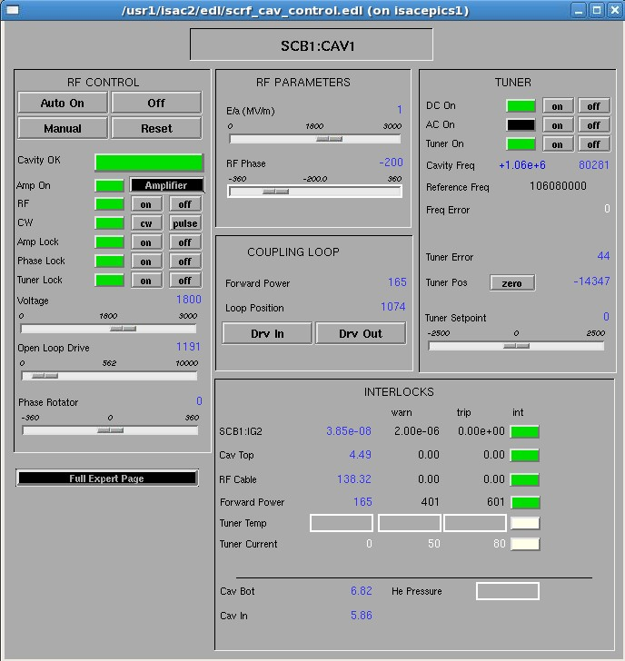
  - Once ‘Cavity Ok’ green, procedure successful.

Figure 1 – EPICS SCRF cavity device page.

