PROCEDURE for STARTING SCRF CAVITIES from LOCAL CONSOLE
(when 'AUTO-ON' Fails or Starting from Scratch)
-TA as per CB & DL, Jan. 2013

- Initial Conditions:

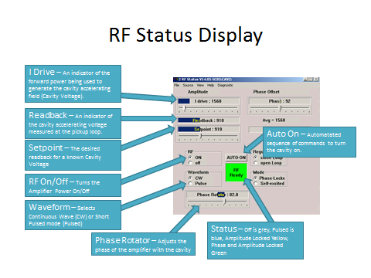

- ensure RF is turned OFF.
- ensure RF is in PULSE mode, NOT continuous wave (CW).
- ensure the Amplitude Open Loop Drive (I Drive) setpoint is @ '0.'
(*the above prevent risk of high RF power driven into a cavity when amplifier turned on)
~~~~~~~~~~~~~~~~~~~~~~~~~~~~~~~~~~~~~~~
- ensure that LOOPS for Amplitude/Phase/Tuner are OPEN (locks off).
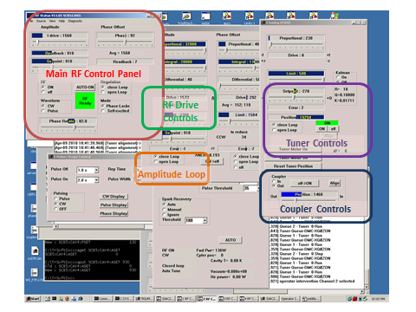

- record Coupler initial position (usually ~1000, equivalent to ~100W; coupling loop position >3000 = strongly over-coupled!, Pfwd may be too high).
- record Phase Rotator initial position (epics readback not reliable for this!).
- connect oscilloscope ('scope) via BNC to desired cavity output (labeled ‘Monitor’); 10mV, 10ms scales.

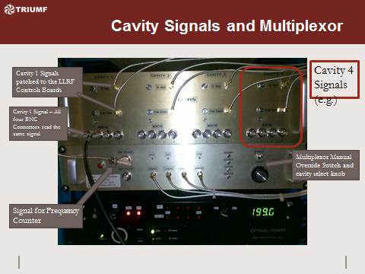

- Reset & turn on amplifier if tripped, then turn on RF in pulse mode.

*A pulsed signal is chosen such that if multipacting (MP) is a problem, the pulse is not on long enough to initiate a full avalanche from the electron showers.

- Increase Amplitude Open Loop Drive setpoint to ~1000 (max. 4000!). Change RF to CW mode & adjust Amplitude Open Loop Drive setpoint to achieve ~150/100W SCB/SCC forward power (Pfwd, cavity accelerating field/voltage) as read on the amplifier. If amplitude readback present >~100 (lower isn't likely real), skip to step 5; otherwise, resume pulse mode. If only a noisy flatline is present on the 'scope (no 'decaying pulse' signal),

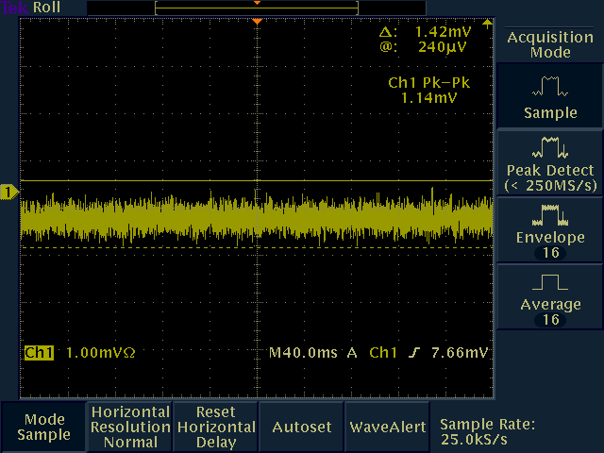

scan the Phase Rotator (Shifter) through 360 degrees to maximize the 'scope signal.

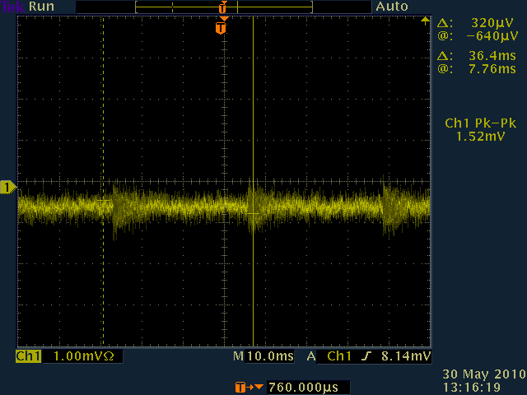

*As Rotator Phase is moved away from optimal, the field measured in the cavity weakens and eventually disappears.

- Note the Coupler's initial position for later comparison. Increase (insert) the Coupler by ~1000 (max. 4000) looking for >10mV peaks on the scope (this is the approximate threshold for breaking through MP, 20-30mV is better).

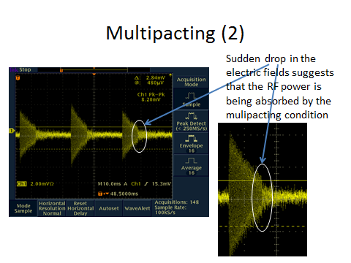
Inserting the Coupler decreases the cavity's Q-value ('quality' factor - ability to store energy, or time to fill/decay; thus, more Amplitude Open Loop Drive is required to achieve the same Pfwd) but increases the acceptance bandwidth for frequency stability.

- Once a smooth pulse shape is observed:

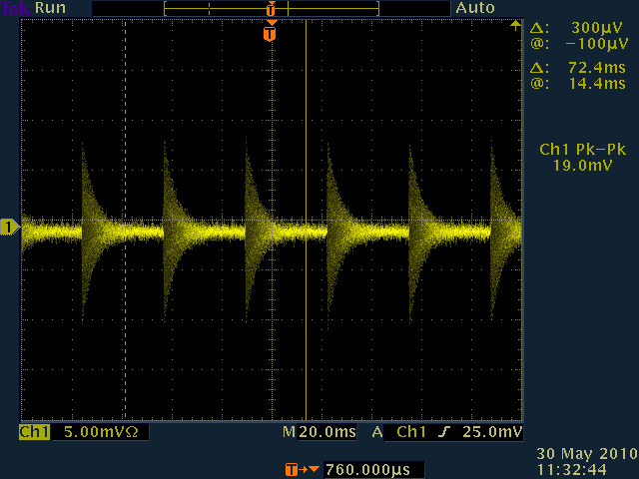

try CW mode looking for an amplitude (voltage) readback >~100, while monitoring Pfwd, on the amplifier. Pfwd should never exceed 400W amplifier trip point! If Pfwd exceeds 200W amplifier warning:

-immediately return to pulse mode,
-decrease Amplitude Open Loop Drive by ~500,
-increase Coupler looking for >10mV on the 'scope
-try CW again.

If multipacting is surpassed, the 'scope trace pulses should have consistent amplitude (no more decaying) >10mV.

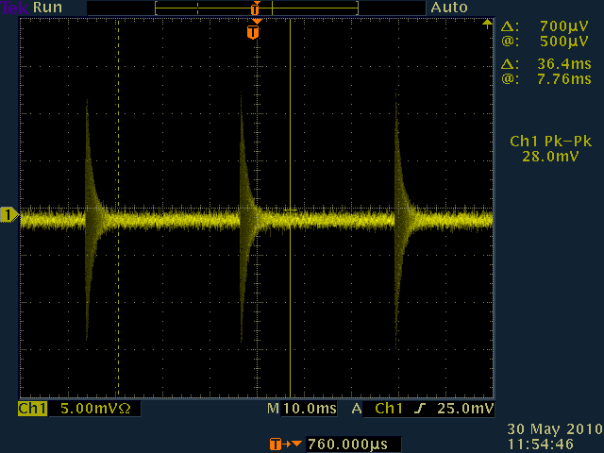

*If no Amplitude readback is present (& fields decay/disappear on scope), MP onset is likely:
-resume Pulse Mode,
-increase Coupler by ~500 looking for stronger signal on scope >10mV,
-try CW again (as CW is switched on, MP may still be initiated since the slow build up of the field in the cavity may not break the MP barrier fast enough).

Repeat until Amplitude readback present above ~100.

If Coupler is fully inserted with no Amplitude readback; resume pulse mode, increase the Amplitude Open Loop Drive by ~500 (never exceeding 4000 w/out expert approval) or as needed to achieve ~200/150W (SCB/SCC) Pfwd, & try CW again.

If still no Amplitude readback present above ~100 w/ Amplitude Open Loop Drive 4000 & Coupler fully inserted, strong MP is implicated: cavity likely needs conditioning or expert permission is required to exceed Open Loop Drive above 4000 maximum.

- Once in CW mode with stable Amplitude readback >100 achieved, as long as the 'scope signal has a smooth pulse shape consistently stronger than 10mV, MP should be overcome. It is then necessary to increase the field in the cavity while maintaining ~140W Pfwd. Slowly decrease the Coupler back down toward ~1000 (or its initial position), watching the amplitude readback increase (exponentially!).

As the Coupler is withdrawn from the cavity, the Qext (external quality factor ~ ability of cavity to store energy relative to power lost through port) of the cavity increases, minimizing the input power required & increasing the cavity voltage (amplitude readback) for a fixed Pfwd.

When amplitude readback reaches 50% setpoint, check phase rotator to maximize readback & minimize Pfwd. Monitor Pfwd constantly!: as long as CW signal on ‘scope is >>30mV, MP recurrence is unlikely;

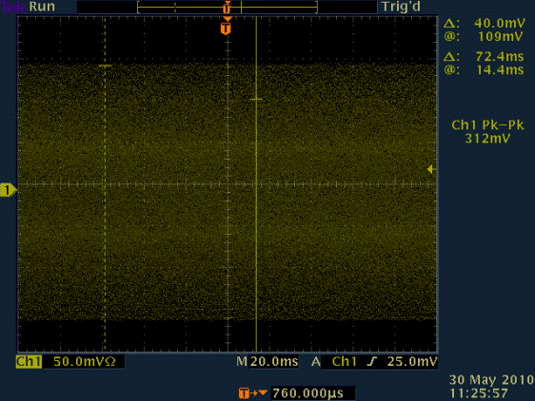

Compensate with Amplitude Open Loop Drive to maintain ~140W.

Continue withdrawing coupler until amplitude readback just exceeds setpoint. If readback ever far exceeds setpoint, compensate by driving coupler in (&/or reducing Amplitude Open Loop Drive) until readback just surpasses setpoint. Ensure coupler stops moving when commanded; if not, send it in the opposite direction.

If Amplitude readback is lost at any time, MP has likely recurred & one must start over.

- Once Amplitude, Coupler, & Pfwd conditions are met as follows:

-Amplitude readback slightly exceeds setpoint,
-Coupler position is near ~1000 or its initial value, &
-Pfwd is ~140W;

close Amplitude Loop of cavity
(at this point it self-regulates, and Open Loop Drive setpoint disappears).

If amplifier trips or Pfwd increases on amplitude lock, phase rotator not properly set.

Once Amplitude lock is achieved, Auto-on may be possible. If this fails, start over & skip Auto-on at this point.

- Check the Rotator Phase of the cavity.

If the phase between the cavity and amplifier is incorrect, the field in the cavity will be reduced due to deconstructive interference. Since the amplitude regulation loop is maintaining the correct cavity accelerating voltage, improving the phase will minimize the RF power required to generate this voltage.

Slowly adjust the Phase Rotator (1 degree steps) to minimize Pfwd, while using Coupler to compensate maintaining Pfwd ~140W.

A change in Coupler position results in a frequency shift due to a change in the cavity's internal geometry. The cavity frequency must then be matched to the Main Oscillator frequency (difference is dF) by tuning the phase (initiating the tuner loop) as follows:

- If Tuner Error is large on 'tuning PID0' page, adjust the Tuner setpoint so that the error is minimized and oscillates around '0.'

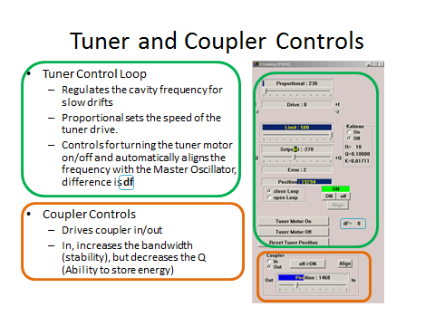

- Ensure Tuner is ready (on), then press Align to start the automated sequence looking for |dF| ~<20.

- Click Auto-on (closes all loops: should be tuner & phase at this point).

If a cavity trips on high Pfwd when trying to phase lock, recheck the phase rotator or temporarily lower the setpoint of the cavity to ~75% when repeating the starting procedures. Once the cavity is phase-locked, slowly increase the amplitude setpoint to the original value.

Often the cavity setpoints are at a position just below the stable operating point of the cavity. When attempting to close the phase loop, the combination of amplitude, tuner and phase loops may overcompensate for the cavity voltage and phase, tripping the cavity.

If this continually fails, the PID settings may need to be adjusted by an SCRF expert.

Cavity Instability Troubleshooting ('ok' signal flickering, Pfwd unstable...)

If Amplitude (I ~ Current) Drive readback (RF (PID1) page) nearing limit: marginally withdraw coupler, or slightly increase amplitude limit but ensure Pfwd does not increase.

Amplifiers heat up over time & Pfwd should thus be checked periodically. If it exceeds 140W, the phase of the amplitude loop may have drifted:

- Open Phase Loop.
- Check Phase Rotator to minimize Pfwd.
- Check Coupler to maintain ~140W.
- Close phase loop.
- Recheck Tuning Frequency Error (if necessary [dF >~20], open tuning loop & realign).
- Auto-on if tuner loop was opened.

If Phase Rotator found to be ok, an offset in Phase Loop Parameters may be resulting in the control loop converging on an equally offset position (which may also increase Pfwd demand):

If the Phase Offset Drive readback (RF (PID1) page) is consistently either high or low by ~1000+, or nearing its limit; the Tuner Loop setpoint on the Tuning PID0 page may be adjusted slowly in closed Tuning Loop to minimize the Phase Offset Drive (requires time/patience). If the Phase Offset Drive readback is fluctuating +/- ~1000, the PID settings will need to be adjusted by an SCRF expert.

Conditioning:

Short Pulse (for MP; pulse mode, rep 35ms, width 1024us)
i. Turn RF OFF.
ii. Set Amplitude Open Loop Drive ~1000.
iii. Turn RF ON.
iv. Set CW mode, adjust Amplitude Open Loop Drive for Pfwd ~150/100W SCB/SCC.
v. Resume pulse mode.
vi. Drive Coupler to maximum position (~4000).
vii. Set CW. If no voltage present ~>100, increase Amplitude Open Loop Drive for 200/150W Pfwd SCB/SCC. Resume pulse. After a few seconds, try CW again. If voltage still not rising; turn RF off, check amplifier Pfwd locally (EPICS sometimes less accurate). More time may be required.
viii. If amplitude achieved above 15 mV, decrease Amplitude Open Loop Drive so Pfwd doesn’t exceed 200/150W SCB/SCC.
ix. Once Amplitude readback present >~100. Follow standard procedure from step 5.

Long Pulse – (may provide sufficiently high RF power to condition through strong MP; CW, off 1s, on 2s).

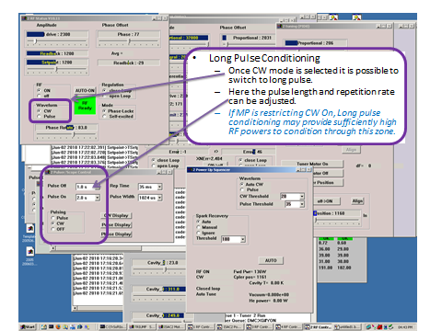

*Use CW mode first to set ~150/100W SCB/SCC Pfwd with Amplitude Open Loop Drive, then resume pulse mode.*

i. Connect 'scope & set time/amplitude scales ~10ms/2mV.
ii. While pulses not visible or have amplitudes below 10mV
a. Fully insert Coupler (>3000)
b. Scan Phase Rotator looking to increase pulse amplitude or punch through MP more often.
c. Increase Amplitude Open Loop Drive (max. 4000!), repeat b.
iii. Once pulses consistently have amplitudes above 10mV, set CW mode.
a. If amplitude of signal falls below 10mV, MP still occurring: resume pulse mode; repeat ii.b or after 3 attempts repeat ii.c.
b. If amplitude achieved above 15 mV, decrease Amplitude Open Loop Drive so Pfwd doesn’t exceed 200/150W SCB/SCC.
c. Once Amplitude readback present >~100, follow standard procedure from step 5.

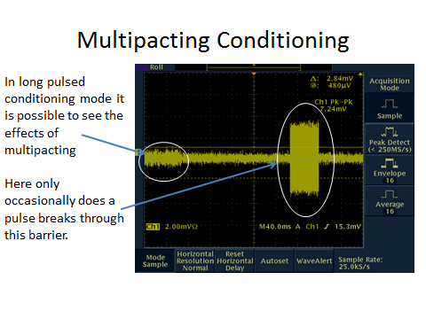

General Info:

SCB/SCC freq: 106.08 /~141 MHz.
Phase Rotator/Shifter: cavity vs. amplifier/(bunch).
Cavity Phase: with respect to other cavities; set by Accelerator Expert for maximum acceleration -25degrees for bunching.
Coupler: changes cavity's internal geometry, stability & ability to store energy; results in frequency shift
Coupler direction | in | out
Qvalue (ability to store Energy) | decreases | increases
acceptance bandwidth (stability) | increases | decreases
Pfwd (closed amplitude loop) | increases | decreases

Frequency Regulation (Tuner Loop):
Frequency has to be constant to maintain synchronicity between RF field & particles. Tuner Loop matches/regulates cavity's Amplitude Loop frequency to amplifier / master oscillator frequency for slow, significant shifts (+/- 4kHz) or static shifts (30kHz). The following can disturb frequency: vibrations (construction, pumps, valves, noise), pressure changes (cryo plant, valve opening, RF load), Radiation pressure of high RF field: Lorentz force, fabrication tolerance.

Low Level RF (LLRF) self-oscillating loops (Amplitude, Phase):

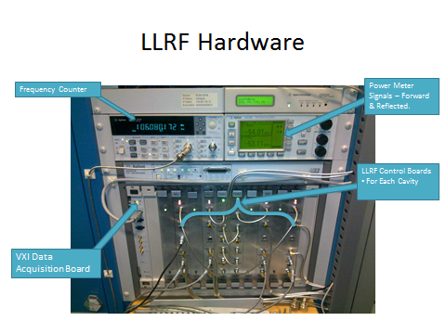

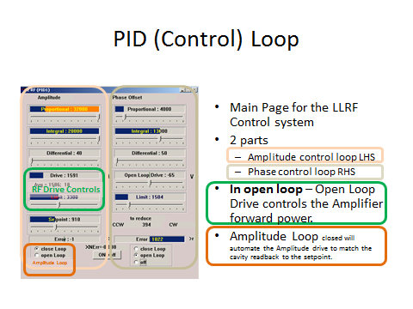

compares pickup signal to phase of master oscillator & amplitude setpoint, adjusts output to have phase & amplitude constant (regulates loop attenuation & phase to keep pickup signal constant with respect to cavity bandwidth (Qext)) for fast, small perturbations of frequency (<20kHz). Amplitude & phase stability are important for maximum transmission of beam. If accelerating field decreases in a cavity, particles would be 'late' in the next one-->optimal acceleration is lost.

Amplifier troubleshooting:

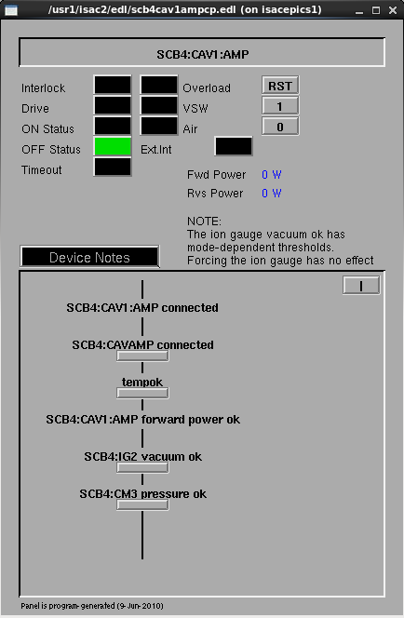

Temperature interlocks preventing an SCRF amplifier from turning on should be forced (RF interference known to cause thermocouple readings to be unreliable). Forces are meant to be permanent but become lost during IOC reboots (due to PVs not in save tune file?).
'Air' interlocks do not prevent an amplifier from being turned on (from EPICS).

Vacuum interlocks are 'mode' dependent & more strict than an ion gauge being 'ok' (<7e-5 Torr). Warm/cold modes require 5e-5 Torr, norm mode requires 2e-6 Torr. If an amplifier cannot be turned on in norm mode, an expert may be consulted to determine whether another mode is an option.

EPICS Pfwd readback less reliable than local amplifier in reflecting reality, & updates less frequently.

If 'Amp on' cannot be achieved in EPICS, check locally at amplifier that Main Power switch is on & 'On' button is illuminated:

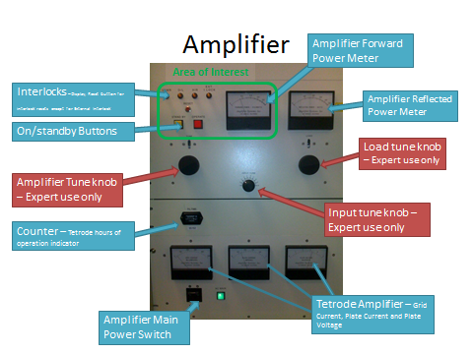
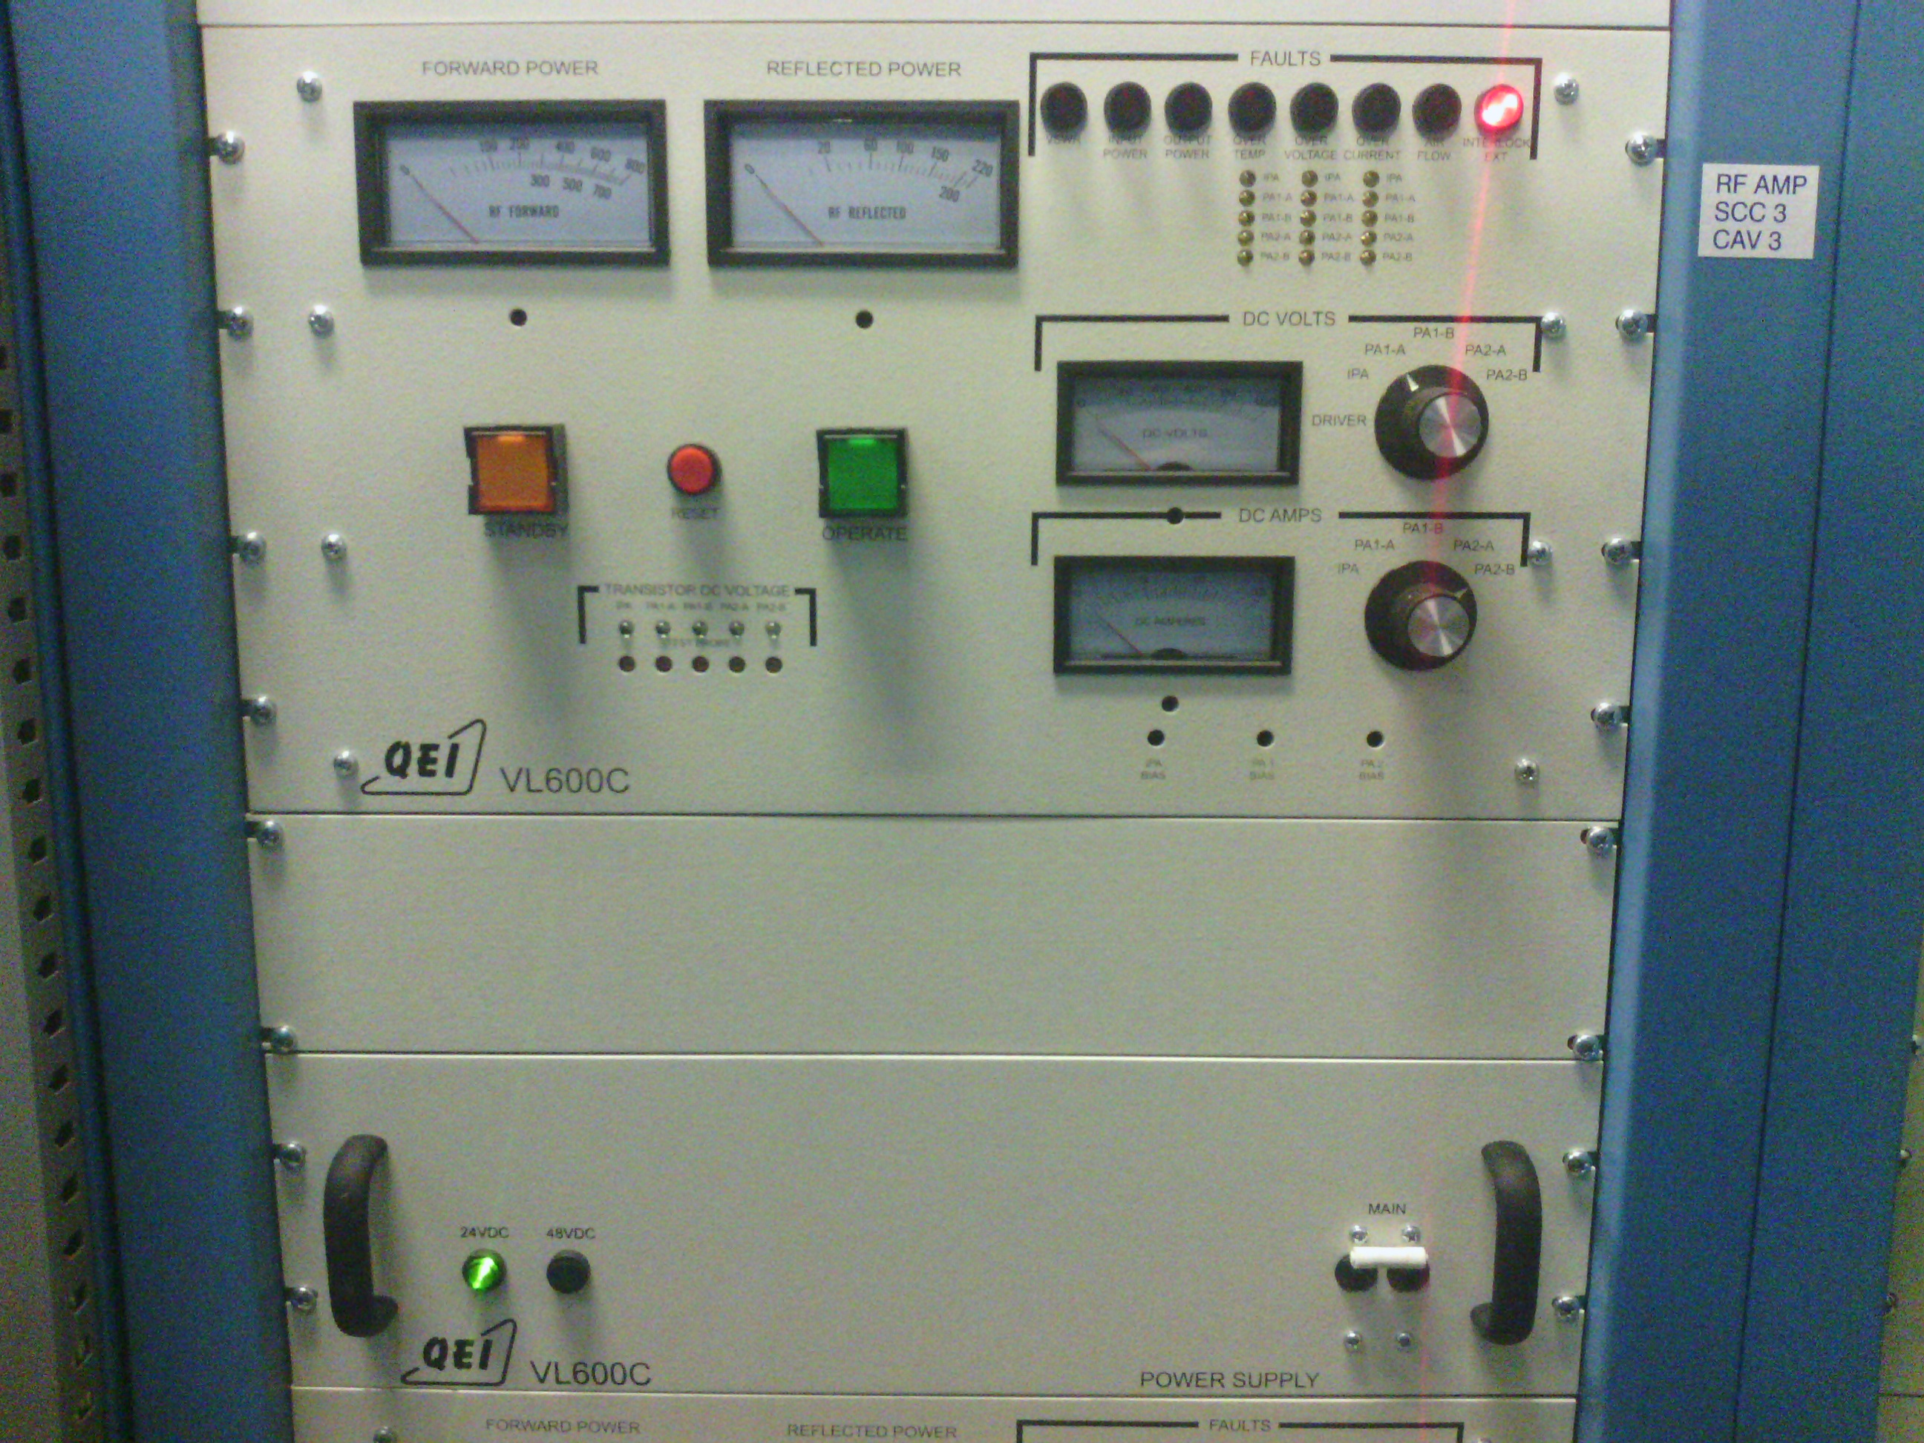

No power reading present troubleshooting:

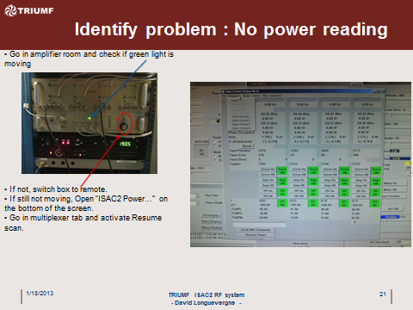

Go in amplifier room & check if green light is moving. If not, switch box to remote. If still not, open 'ISAC2 Power...' on the bottom of the screen. Go in multiplexer tab & activate resume scan.

Tuner troubleshooting:

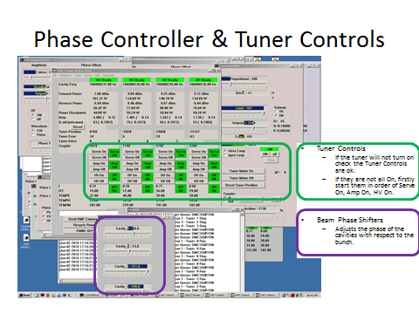

If Tuner will not turn on, check whether the Tuner Controls are ok (tuning (PID0) page). If they are not on, start them from top→bottom: servo On, Amp On, HV On.

