Minimizing ISAC-I RF Amplifier Reflected Power by Adjusting Tuner Setpoint Locally
TA, April 27, 2014

If an ISAC-I RF cavity amplifier is tripping often (including during startup) & doesn’t appear to be related to vacuum or an amplitude limit, the problem may be high reflected power.

Start a striptool plotting the problem cavity’s:
- amplitude setpoint/readback,
- vacuum gauge in its interlock chain, and the
- Final Power Amplifier’s (PA’s) & Driver’s Reverse Powers
(obtained from the cavity’s ‘Amplifier Mon[itor]’ page).

Turn on the cavity at a setpoint of ~400 using ‘Auto On.’

Increase the amplitude toward the desired setpoint, note the reflected powers when it trips.

Restart the cavity at ~400 amplitude.

From the local ISAC-I RF console, note the Tuner setpoint (Tuning (PID0) window →setpoint, see Figure 1 – ensure the correct cavity is selected from the Taskbar, Tank 3 (DTL3) is shown).

Adjust the tuner setpoint to minimize reflected power as necessary while restoring the desired amplitude (this requires a laptop or coordination of two operators, a reflected power scale is also visible on the local amplifier but may not be sensitive enough depending on the cavity).

If the cavity trips, restore the initial tuner setpoint & begin again more slowly.

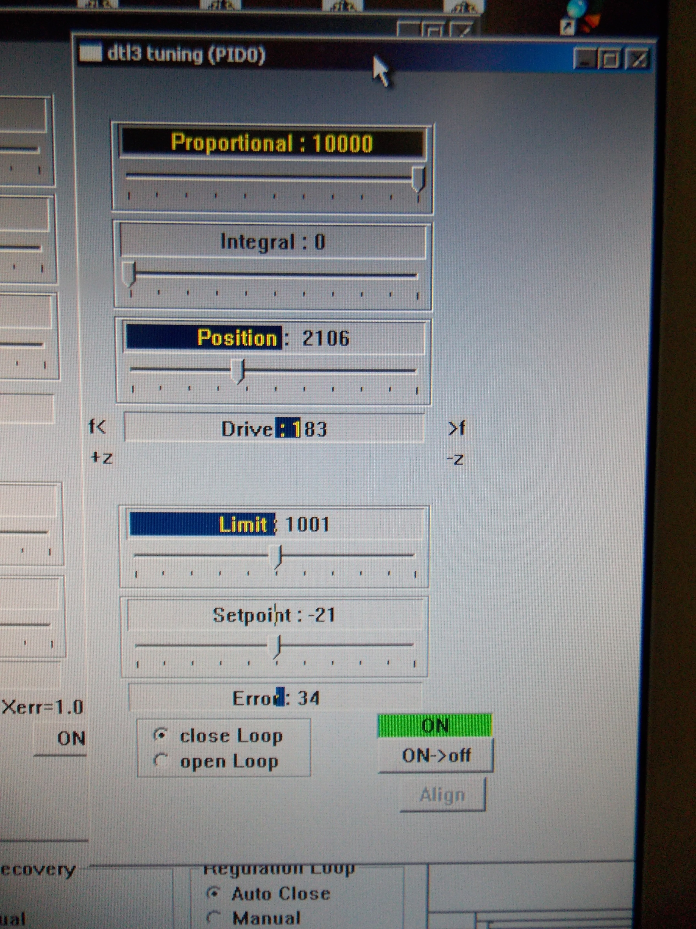
Figure 1 – Tuning (PID0) window for Tank 3 (DTL3)

