ISAC-II Accelerator Vault Access
April 19, 2010 by Jon Aoki in consultation with John Drozdoff and Marco Marchetto

ISS Requirements

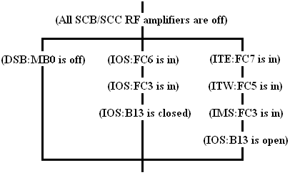

Procedural Requirements

- It is good practice to close SCB:IV2A, SCB:IV2B, SCB1:IV1 and SCC3:IV2 when opening the vault. These valves can be opened/closed as required, but it is preferred that they not remain open for long periods of time.

- A radiation survey of the vault is required on opening if beam has been accelerated through the vault since the last survey. If beam has only drifted through the Vault (no acceleration through the SC Linac), a survey is not required.

- A portable O2 sensor is required for entry into the ISAC-II Accelerator Vault.

