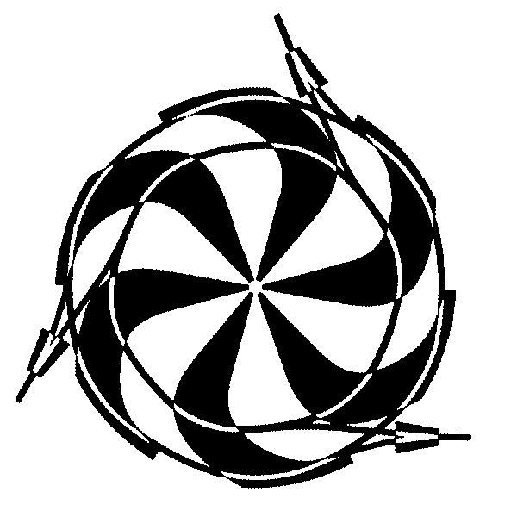

TRIUMF

TO: ISAC operations, M. Gallop, John McKinnon. DATE: 23 June 2009

FILE: disconnectmemo09

FROM: M McDonald CC F Mammarella, P Bricault

RE: ITW Einzel Lens power supply power disconnect.

With the installation of the ITW Einzel lens power supply we need for the time being to lock this disconnect in the off position with a personal lock, whenever there is entry into the ITW high voltage power supply room (ITW Faraday Cage), or access to the west target station.
It should be locked out when the bias supply power disconnect is locked in the off position.

When the installation is finalized there will be a Standard Interlock lock installed on the disconnect and
it will be part of the lock sequence. This to be completed before the September 09 shutdown.

Entry into the ITW Faraday cage could be coordinated with myself, Ray Dube, or Robert Laplante so that we may place one of our locks on the disconnect and the individuals entering into the ITW Faraday cage may also place their lock on the disconnect. As I indicated this will be an interim solution until the present system has the new disconnect added to the system.

Regards Mike

