Authored by: Jonathan Aoki
Reviewed By: Friedhelm Ames
Date: February 26, 2010

Testing / Purging the ITW FEBIAD Gas System

Initial Conditions:

- The manual valve (at the target module) must be opened by the Target Hall Coordinator (or alternate).
- ITW should be under “good” vacuum (ITW:PNG1 < 1e-5Torr).

Note: The following procedure is to be completed before source conditioning begins.

Instructions:

1) Striptool ITW:PNG1
During the procedure below, keep an eye on the source vacuum. Turn off ITW:IG1 to prevent damage to the gauge. We do expect the vacuum to fluctuate when valves are opened/closed but it should remain below 5e-4Torr.

2) Open ITW:SV6 briefly
There may be trapped gases in the volume behind the valve. The goal is to pump the volume out without the target vacuum going too high. Once the target vacuum has recovered, try briefly opening ITW:SV6 again. Repeat this process until the target vacuum has recovered and you are able to keep ITW:SV6 open.

3) Pump out the volume behind ITW:SV5
Repeat the steps in 2) with ITW:SV5. At the end of this step, both ITW:SV5 and ITW:SV6 should be open.

4) Pump out the volume behind ITW:SV4
Repeat the steps in 2) for ITW:SV4. Once the volume has been pumped out, close ITW:SV4.

5) Pump out the volume behind ITW:SV7
Repeat the steps in 2) for ITW:SV7. Once the volume has been pumped out, close ITW:SV7.

6) Pump out the volume behind ITW:SV8
Repeat the steps in 2) for ITW:SV8. Once the volume has been pumped out, close ITW:SV8.

7) Pump out the volume behind ITW:SV9
Repeat the steps in 2) for ITW:SV9. Once the volume has been pumped out, close ITW:SV9.

8) Pump out the volume behind ITW:VL
Open the ITW:VL device page. The valve accepts setpoints from 0 to 10V. Starting with an increment size of 0.5V, slowly open the valve to 5V. Keep an eye on the vacuum. This valve is non-linear – once it starts to open it will open quickly. If the vacuum in the target starts to rise quickly, decrease the setpoint until the vacuum recovers. From 5V to 7V, slowly step the setpoint up in 0.2V increments. From 7V on, use 0.1V steps. For reference, on Feb 16, 2010 the valve started to open at ~7.7V. Assuming the target vacuum recovers, continue opening the valve until you have reached 10V. Once the volume behind the valve is pumped out, close ITW:VL.

9) Open ITW:SV1 (Helium)
Confirm that the valve opens. The target vacuum should be unaffected. Close the valve.

10) Repeat step 8 to confirm that He bottle is open and enough gas in it. The pressure should rise again when opening ITW:VL. Repeat step 9.

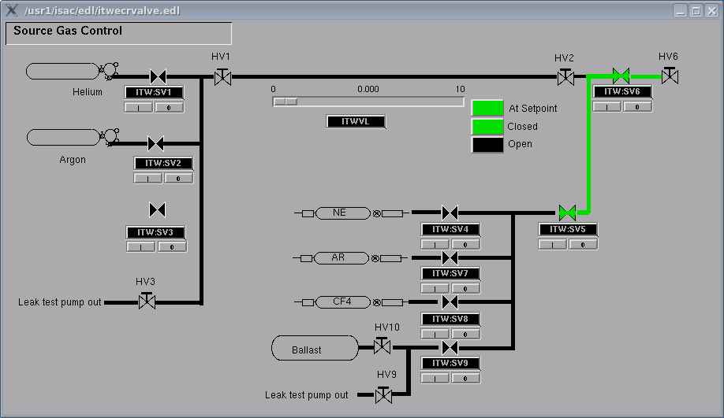
Figure 1 – ITW Source Gas Control EPICS page.

