ISAC Charge State Breeder operational Manual

Introduction

The acceptance of the RFQ accelerator at ISAC is limited to ions with a mass to charge ratio A/q ≤ 30. The following accelerator structures can be operated up to A/q =6 for the DTL and A/q=7 for the SCRF. For ions with a mass below A=30 this is achieved by stripping to higher charge states after initial acceleration by the RFQ to 150 keV/u. If ions with a mass A > 30 amu are to be accelerated it is necessary to increase their charge state in order to stay below this limits. This is achieved by using a Charge State Booster/breeder (CSB). At ISAC an electron cyclotron resonance ion source (ECRIS) has been chosen for this task as it is well adapted to the potentially high currents and to the continuous beam operation.

Principal of operation

At an ISOL facility like ISAC radioactive ions are produced from an on line target ion source system mainly in a 1+ state. They are extracted and accelerated to some 10 keV and the isotope of interest is selected by a mass separator. To increase their charge state they can be injected into a charge state breeder (CSB) and afterwards the desired charge state can be selected by an additional mass separator before they are injected into an accelerator and finally transported to the experiment. Figure 1 shows a schematic for such a system.

primary
beam
mass
selection
charge state
increase
A/q
selection
acceleration
experiment
q= 1+
E= x 10keV
q= n+
E= x 10 q keV
q= n+
E= x MeV/u
Figure 1 Schematic drawing of an ISOL facility with charge state breeding and post acceleration

The charge state breeder at ISAC is an electron cyclotron resonance ion source (ECRIS) operating at 14.5 GHz. It is a modified version of a commercial PHOENIX source from Pantechnik. Within this source a plasma is confined by a longitudinal magnetic field with a minimum in the center of the source. In radial direction the confinement is provided by the field of a magnetic sextupole. The longitudinal field is generated by coils, whereas the sextupole is provided by permanent magnets. The plasma electrons are heated by an rf field at their cyclotron frequency. For electrons at rest the magnetic field corresponding to a cyclotron frequency of 14.5 GHz is B(m₀) = 0.52 T. With increasing energy their relativistic mass increases and the magnetic field corresponding to a cyclotron frequency of 14.5 GHz increases as well. Thus, the maximum energy the electrons can be heated up at a given rf frequency depends on the maximum magnetic field strength.
For the charge breeding the plasma chamber is operated at an electrical potential close to the potential of the target ion source. Ions injected into the plasma are decelerated by this potential so that they can be easily captured by the plasma. After some time, which allows them to collide with the high energy electrons of the plasma they will transform into highly charged ions and they will diffuse to the opposite site of the plasma chamber where they can be extracted. The maximum charge state which can be reached depends on the electron energy, the confinement time and the pressure of neutral gas atoms in the plasma. If a highly charged ion collides with an atom it can be transformed to a lower charged ion again via charge exchange. The operating principle together with some numbers for the PHOENIX source is illustrated in Figure 2.

Figure 2 Operating principal and some characteristic numbers for the PHOENIX charge state booster.

Implementation of the charge breeder at ISAC

The charge state breeder for ISAC is located in the mass separator room. An electrostatic bender (CSB:B1) which can be switched open or closed allows to direct the ions after the mass separator towards the charge breeder. This bender is located in the IMS beam line in between the boxes DB24 and DB26. With a second similar bender (CSB:B4) a Cs ion beam from a small surface ion source (CTIS) can be selected. This beam can be used for setting up the breeder and the following beam transport independent from the operation of the on line ion source. After the charge state breeder the extracted beam is analyzed by a magnetic bender (CSB:MB14) and two electrostatic benders (CSB:B15 and CSB:B16). This allows selecting a specific mass to charge ratio of the extracted ions and thus the desired charge state of the injected isotope. The following benders (CSB:VB17 and CSB:VB20) bend the beam into the vertical direction into the ILT beam line. CSB:VB17, Q17, Q18 and VB20 have shared power supplies with ILT:VB3, Q4, Q3 and VB6 respectively. A diagram of the CSB and beam line installation can be found on TRIUMF drawing number ISK4403D (Figure 3). In the following the different parts of the set up will be described.

Figure 3 Beam line lay out of the charge state breeder in the ISAC mass separator room

Vacuum

The first part of the CSB installation is located in the IMS Vacuum 3 section. A turbo pump CSB:TP4 located at the bender box CSB:B1 has been added. This section includes the 2 electrostatic benders CSB:B1 and CSB:B4 the optics boxes CSB DB1 and CSB DB5 and the test ion source CTIS and is terminated with the gate valve CSB:IV6. The following section up to CSB:IV15 contains the injection optics, the charge state breeder and the extraction optics. At the injection side there are 2 turbo pumps CSB:TP7 and CSB:TP9 and on the extraction side 1 turbo pump CSB:TP14. On both sides of the CSB an additional cryo pump, CSB:CP9 and CSB:CP12, is installed. The next section up to CSB:IV16 contains the magnetic bender and first electrostatic bender of the mass separator. It is pumped by 2 turbo pumps CSB:TP15 and CSP:TP15A. The final part with the bender boxes CSB:B16 and CSB:B17 is integrated in the ILT vacuum section. 2 turbo pumps CSB:TP16 and CSB:TP17 have been added. A schematic of the vacuum installation can be found on TRIUMF drawing number ISK7518D (see Figure 4).
Figure 4Vacuum schematic of the charge state breeder in the ISAC mass separator room

For good performance of the charge breeder a low vacuum pressure in and around the source is essential. Typical pressure values after several days of pumping with the cryo pumps running are.
CSB:IG9 5 ∙10⁻⁸ Torr
CSB:IG12 4∙10⁻⁸ Torr
CSB:IG15 9∙10⁻⁸ Torr.

The EPICS controls window for the CSB vacuum system can be found from the vacuum overview page or under the Vacuum 1 menu (see Figure 5).
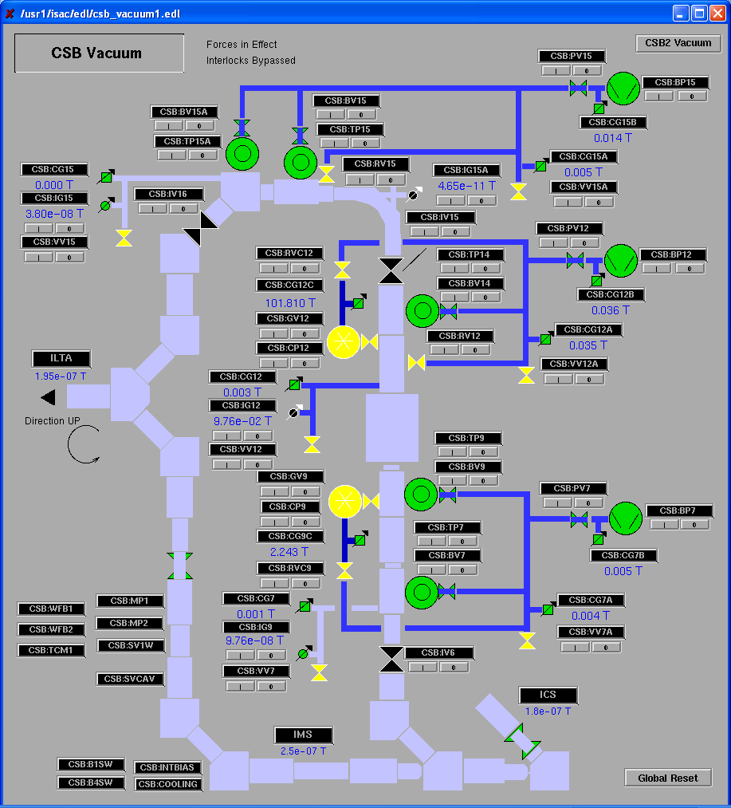

Figure 5 EPICS controls window for the vacuum of the charge state breeder

Gas inlet system

In order to sustain the plasma inside the CSB a small amount of gas has to be let into the plasma chamber. Under normal operation conditions He is used for this. Figure 6 shows the EPICS controls window of the gas handling system. The amount of gas is adjusted by a variable leak valve CSB:VL. Alternatively to the helium oxygen can be used for conditioning the system. Besides this calibrated leaks can be used to set up the CSB and measure efficiencies. The EPICS controls page for the gas inlet system can be reached from the page “CSB optics 2” via “Gases”

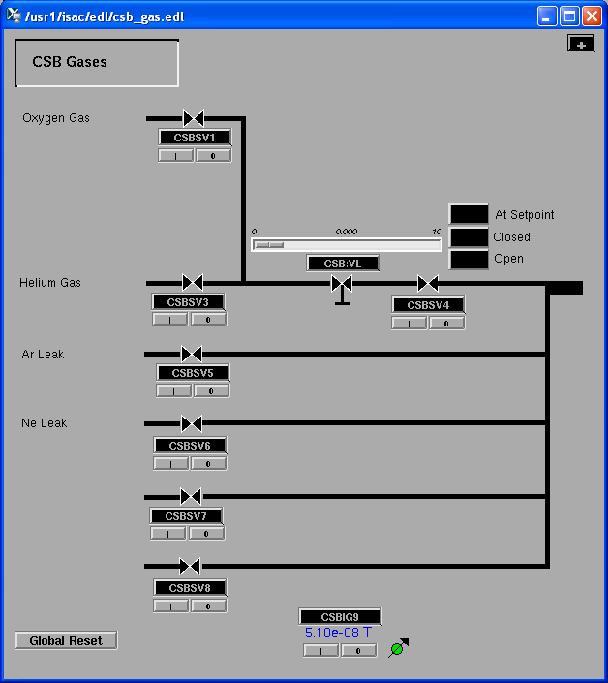

Figure 6 EPICS controls window for the gas inlet of the charge state breeder

After the CSB has been opened or after it was not operated over a long period (>1 week) one has to make sure, that the lines of the gas inlet system have been purged before the CSB is switched on. To do so:
- Prepare a strip tool with the pressure readings from CSB:IG9 and CSB:IG12.
- Make sure CSB:IV6 and CSB:IV15 fron the CSB vacuum controls page are closed.
- The variable gas flow controller CSB:VL has to be set to 0 and off.
- Open gas valve CSB:SV4 and close it again immediately.
- Make sure pressure readings from CSB:IG9 and CSB:IG12 stay o.k, wait at least one minute.
- If pressure rises wait for it to settle down again and repeat opening CSBSV4 for a short time. Repeat until no response in the pressure can be seen.
- Open valve CSB:SV3. If there is any increase in the vacuum readings, immediately close it again and close CSB:SV4. If this happens there is most likely an error in the variable leak valve and a system expert should be consulted before continuing.
- Switch on the variable leak valve CSB:VL.
- increase the setting of CSB:VL in steps of 0.5 every 30 seconds to 4 and continue in steps of 0.1. Watch the vacuum readings. As soon as an increase in pressure can be seen set the setpoint of CSB:VL back to 0 and wrote down the setpoint where the increase in pressure has been seen.
- When the sign at setpoint on the controls of CSB:VL has been reached switch it off.
- Keep CSB:SV4 open.

Cooling water system

The cooling water flow required for the cooling of the CSB magnet coils (entrance CSB:CI and exit CSB:CE) cannot be reached with the pressure difference available from the non-active water system in the mass separator room. Therefore two additional pumps are installed. The first one, CSB:MP1 (booster pump) increases the pressure in the supply line to 190 psi. The second one CSB:MP2 reduces the pressure in the return line to about 10 psi. The latter is also necessary to allow enough water flow in the plasma chamber (cavity) of the CSB without exceeding the maximum allowable pressure of 45 psi in this circuit. CSB:MP2 can be regulated by a variable frequency drive. It regulates the pressure in the return line monitored in a pressure capping tank. Figure 7 shows a schematic of the cooling water system for the CSB. Besides the ECRIS components, the magnetic dipole for the mass analyzer and its power supply and diagnostic elements in front of and after the CSB require water cooling. Those and the CSB middle coil CSB:CM) are connected directly to the non active water system. The waveguide cooling (not shown in this schematic) is supplied by an outlet in the mass separator room. It runs along the waveguide up to the rf generator in the experimental hall and back into the return line at the B1 level in front of the TRINAT laboratory.

Figure 7 Schematic of the CSB cooling water system

The EPICS controls window for the CSB cooling system (CSB:COOLING) (see Figure 8) can be opened from the CSB vacuum controls window. Although there is a pid loop for regulating the pressure, manual control of the system is recommended. This is set up by toggling between REG and MAN on the EPICS control screen of CSB:MP2. (figure 9). Instructions for switching the cooling water system on and off can be found under “Pump Notes” (see below).

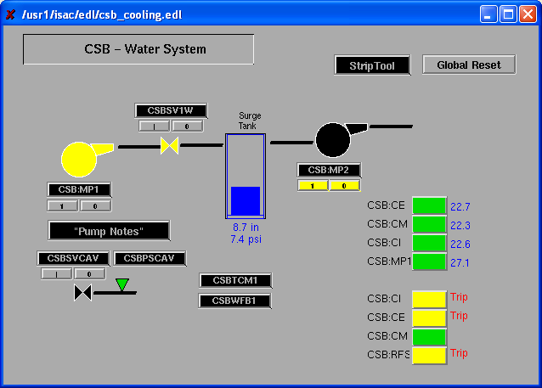

Figure 8 EPICS controls window for the CSB cooling water system

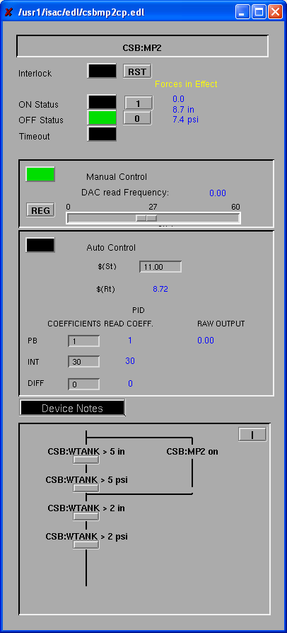
Green if in manual mode
Toggle manual / regulated
Set pump speed

Figure 9 EPICS controls window for CSB:MP2

“Pump Notes”:
switching on the CSB cooling system
Make sure CSB:MP2 is set to "manual control"

Open CSB:SVCAV to allow a minimum water flow.
The level in the surge tank should now slowly rise.
If the level is below 6 in wait until it is above 6 in.
If it is above 20 in close CSB:SVCAV.
Switch on CSB:MP2 at a set point of 25
Open CSB:SV1W, if CSB:SVCAV has been closed before, open it again.
Wait 30 seconds tank level should not fall below 5 in.
If it falls below 5 in switch off CSB:MP2 and
start it again when level in tank reaches 7 in.
If level in tank is above 5 in 30 sec after CSB:SV1W has been opened
switch on CSB:MP1 (There is a delay built in, which allows CSB:MP1 to be switched on only after CSB:SV1W is open for more than 30 sec)
The tank level will stabilize after a few minutes.
It should stay between 5 and 12 in.
Increasing the set point for CSB:MP2 will lower the level and decreasing it will increase the level.
Adjust in steps of 1 if necessary

switching off the CSB cooling water system

switch off CSB:MP2.
This should switch off CSB:MP1 and close CSBSV1W.
If not switch off CSB:MP1 and close CSBSV1W manually
close CSB:SVCAV

February 8, 2010
last update March 19, 2013
Friedhelm Ames

RF system

The rf generator is located in a rack in the experimental hall (behind yield station) and the rf power is transported to the charge state breeder via a water cooled copper waveguide.
The water cooling is done with a loop along the waveguide. The supply of it is connected in the mass separator room and the return in the B1 level in front of the TRINAT laboratory. In both locations it can be closed by manual valves. A paddle wheel flow meter is located close to the valve for the return line at the B1 level.
The rf generating system consist of a signal generator (BNC model 845) and an amplifier (CPI model VZU-5997AD). Both devices are controlled via EPICS. The controls window can be reached from the CSB Optics 2 page by clicking on CSB:RFS. It is shown in Figure 10. In the upper part the frequency and amplitude of the signal generator can be set. Normal operating frequency is close to 14.5 GHz. and the amplitude at -10 dBm.
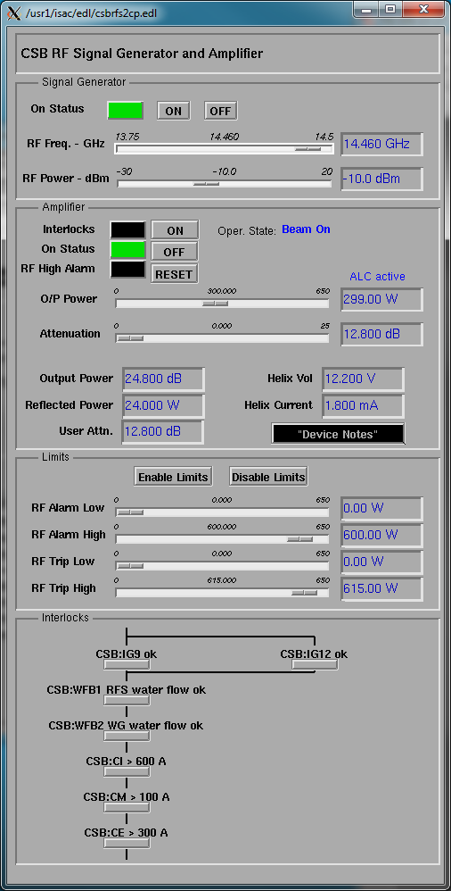
Figure 10 EPICS controls window for CSB rf system

The lower part of the window controls the amplifier. It can be switched on and off and the output power level can be set. It operates in an automatic level control mode (ACL) and adjusts attenuation of the ingoing signal from the signal generator. The attenuation factor can also be set manually. Besides this it offers the possibility to set alarm and trip levels for the output power.

Start up of the charge state breeder

There are three EPICS control screens for the CSB optics and the surrounding beam lines:

CSB optics 1 : injection optics and test ion source
CSB optics 2 : charge state breeder
CSB optics 3 : extraction optics and mass analyzer

Stabilization of the plasma inside the charge state breeder will take several hours. Therefore, it is recommended to switch it on well in advance (> 1 day) of the time it is scheduled for use.
- Before switching on make sure the cooling water and the vacuum system both are working properly see previous chapters). Open gate valves CSB:IV6, CSB:IV15 and CSB:IV16. The Faraday cups on both sides of the charge state breeder CSB:FC5 (on CSB optics 1) and CSB:FC14 (on CSB optics 3) should be put in.

- The benders CSB:B1 and CSB:B4 have to be set according to the desired operation mode. AC switch CSB:AC14A on CSB optics 1 page has to be switched off before the position of the benders can be changed.

beam mode | CSB:B1 | CSB:B4
ISAC target to CSB | closed | closed
ISAC target to experiment, no CSB | open | N/A
ISAC target to experiment, test source to CSB | open | open
no ISAC beam, test source to CSB | N/A | open

- Make sure the gas inlet system has been purged (see chapter 2.2) and CSB:SV4 is open.

- In the vertical beam line (ILTA optics 1) the polarity of the deflector plates ILT:XCB7 has to be set to “CSB” if beam from the charge breeder is to be sent to the experimental hall.

- Switch on AC switches on the CSB optics 1 and CSB optics 3 pages. If either bender CSB:B1 or CSB:B4 is open CSB:AC14A should not be switched on

- Switch on all beam line optics on the CSB optics 1 and CSB optics 3 pages. Switch on CSB:MB14.

- If beam from the test ion source is desired switch on all power supplies for the test ion source CTIS. Make sure CTIS:HTR current and voltage are set to 0.

- Switch rf amplifier and signal generator in experimental hall on. The cathode of the amplifier tube needs about 10 minutes to warm up. After this the “READY” indicator should light up.

- Make sure cooling water system is running according to section 2.3

- Make sure vacuum in the CSB beam line is o.k. Cryo-pumps should be operating and reading on CSB:IG9 and CSB:IG12 is below 1e-7 T.

- Open gate valves CSB:IV15. Keep CSB:IV6 and CSB:IV16 closed for the initial starting of the plasma. Depending on the pressure and the cleanliness of the plasma chamber it may result in a vacuum burst.

- Insert Faraday cups CSB:FC5 and CSB:FC14

- Make sure magnet power supplies CSB:CI, CSB:CM, CSB:CE from CSB optics 2 page are set to 0 A. Switch the power supplies on, set increment on all 3 supplies to 1 A. Slowly increase the current in all 3 supplies in such a way that the difference between the output of CSB:CI and CSB:CE is not more than 400 A. A higher difference will result in a high mechanical stress to the CSB assembly. The nominal operating values for the currents are
CSB:CI 1050 A
CSB:CM 255 A
CSB:CE 752 A

- When increasing the magnet currents some vacuum ion gauges in the IMS, MEBT and HEBT section may switch off due to electromagnetic interference. It is advisable to force those gauges temporary If necessary restart them. Remove all forces after magnets have reached their final values.

- Switch on power supplies for injection and extraction optics on CSB optics 2 and set them to their nominal values. For a desired bias voltage of 15 kV nominal values are
CSB:IE1 5300 V
CSB:IE2 540 V
CSB:EE 4500 V 0.7 A
CSB:DELTAV 17 V (only necessary if beam from test ion source is injected)

- Switch on high voltage CSB:HVBIAS and increase in steps of 1000 V up to the desired high voltage. For accelerated beams the desired voltage is 2.04 kV *A/Q. The desired charge state for the radioactive isotope will be specified before the run by a beam delivery expert.

- Open rf controls window CSB:RFS from page CSB optics 2.

and set power to 50 W. Wait until “Fwd Pwr” readback goes up to 50 W (ca 1 min). “Rev Pwr” should stay close to 0 W. Increase power in steps of 10 W up to 350 W if not specified differently by system expert. Watch vacuum reading of CSB:IG9 and CSB:IG12 and Faraday cup current on CSB:FC14. If the vacuum goes above 2∙10⁻⁷ Torr or the Faraday cup current goes above 0.5 mA wait and let it settle down before increasing the rf power further.

- The system should be kept like this for several hours to let it stabilize.

- If beam from the test ion source is to be used put in Faraday cup CSB:FC5 and set values for the extraction optics of this source. Typical values for the operation at a high voltage bias of 15 kV are:

CTIS:EE 500 V
CTIS:EL 1600 V
CTIS:EE2 2600 V

- Set CTIS:HTR voltage to 5 V and increase current in steps of 0.1 A to 2.2 A. With those settings the current on Faraday cup CSB:FC5 should increase to about 15 nA. This can take several hours for stabilization.

Beam tuning

After the CSB and CTIS have stabilized beam tuning can commence. The most important parameter for the charge breeding is the difference between the CSB high voltage and the energy of the injected ions. It has to be adjusted to an accuracy of about 1 V to have the highest efficiency for stopping the ions in the plasma. If beam from the on-line targets is injected the CSB high voltage has to be set to the correct values. With the present power supplies at the target stations those values are.

HV_{CSB} = HV_{ITW} + 14 V
or
HV_{CSB} = HV_{ITE} -4 V

In the case of beam from the test ion source both the CSB and the test ion source are connected to the same high voltage power supply. The difference in beam energy can be adjusted by CSB:DELTAV. The optimum is usually at about 17 V.
CSB tuning consists of three distinct phases. First the extracted beam optics should be adjusted to achieve maximum transmission through the CSB mass separator and to the final destination. Secondly, the injection optics elements have to be optimized for the desired beam either from the test source (CTIS) or from the on-line ISAC targets. The last step is to adjust the charge breeder settings. Several rounds of all three steps may be necessary to reach optimum performance.

Tuning of the extracted beam

Even with no beam injected the extracted beam from the charge breeder is around 100 micro Amps, depending on the plasma conditions. It consists of ions from the support gas (mainly He), the residual gas and a small contribution from the plasma chamber materials. All ions occur in several charge states. At higher masses there are also molecules present. Therefore, it is essential to set up a beam tune, which allows for a good mass resolution in order to separate the desired ions from the background. Values for the optics settings can be found on the “beam dynamics” page or loaded from a former saved tune. Slit settings for normal operation should be:

CSB:YSLIT14 10 mm
CSB:YSLIT15 6 mm
CSB:YSLIT16A 3 mm

A mass scan should be performed in order to verify the calibration for the mass scaling and check for possible background at the desired A/Q value. This can be done using the correlations tool from CSB optics 3 page and CSB Mass Correlation (Figure 11). The high voltage bias (HV) of the CSB and the magnetic field (B) of the analyzer magnet are read by the program and it calculates the A/Q value according to the formula
$$\frac{A}{Q}={\left(B+C_{1}\right)}^{2}⋅\frac{C_{2}}{\text{HV}}$$
The parameters C₁ and C₂ can be determined with known A/Q values from different charge states of residual gas ions like Oxygen and Argon. Nominal values are
C₁=0 and C₂=0.0535,
with the magnetic field in Gauss the high voltage in Volts and A/Q in amu/e.

Before starting a mass scan insert Faraday cup CSB:FC16A and switch it to “autorange” and “log10 enb” Make sure parameters C1 and C2 are correct and set start mass (low scan limit), end mass (high scan limit) and scan step. A typical value for the step size is 0.003 A per 0.1sec. The scan can be started by first pressing “prepare up”, which moves the magnet to the start position, and then pressing “up”. A typical mass spectrum in the most interesting range up to mass 10 is shown in Figure 12. The highest beam intensity usually can be found at mass 4 from the He support gas and on the different charge states of ¹⁶O, ¹⁴N, ¹²C and ⁴⁰Ar. If the mass scan looks significantly different from the one in Figure 12 most likely the parameters C1 and C2 are not set correctly. If this cannot be fixed by changing those parameters or if C2 has to be changed by more than 10% of it’s nominal value a system expert has to be consulted before continuing. The routine allows also for saving the obtained mass spectra for off line data analysis. To do so after a mass scan click on “Delete Old Data”, right click on the graphic window, schose dump to file with the file name “plot.txt”. After this click on “Clean,Show/Save Data”. This will open a window with the data columns in it. Close it and press “Set timestamp”. This should have saved the data on a file with the date and time in its file name.
A beam with a mass to charge ratio close to the one where the charge breeder is going to be operated should be chosen for tuning. The beam intensity should be maximized first on Faraday cup CSB:FC16A, and then up to the final destination.
After tuning is finished C1 and C2 can be adjusted to match the A/Q value (if possible, better than 0.01 amu/e) to improve the accuracy of the mass calibration. This will allow easy mass scaling to a low intensity radioactive beam.

- 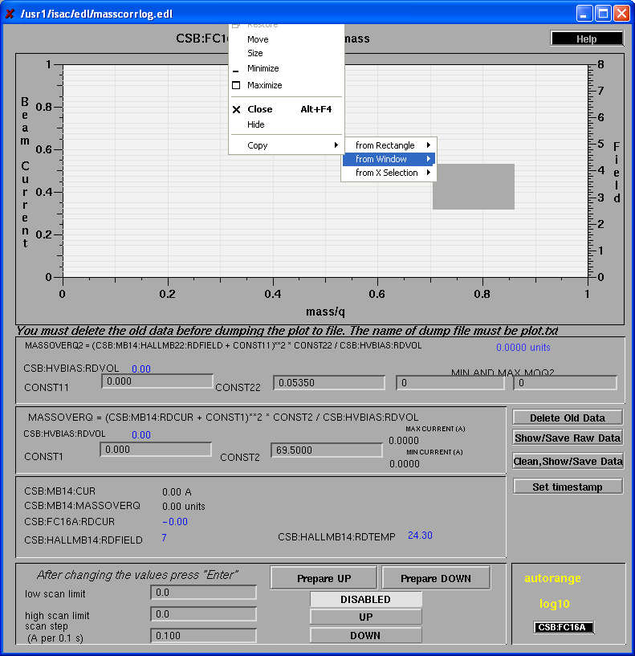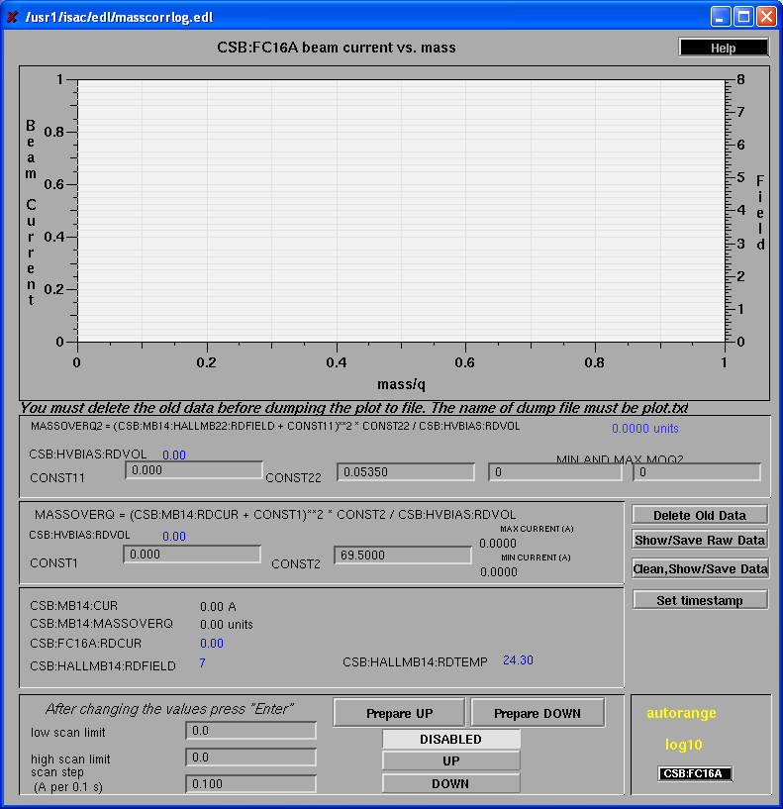

Figure 11 EPICS controls window to perform a mass scan of the beam extracted from the CSB
Figure 12 Mass spectrum from the charge breeder source up to A/Q = 10 with no beam injected.

Tuning of the beam injection

The injection optics can be optimized only by observing the extracted charge bred ions. Tuning should be first performed with the test ion source (CTIS) or with a stable isotope of the same element as the radioactive isotope from the ISAC targets. The magnet CSB:MB14 has to be set to an A/Q value corresponding to the desired isotope and charge. A charge state close to the maximum in the expected charge state distribution and with a minimum of background ions should be chosen. If ¹³³Cs from the test ion source is injected the maximum in the charge state distribution is at about Q=20, with A/Q =6.65. This is very close to ⁴⁰Ar⁶⁺ with A/Q= 6.666 and thus has a high background level. Close by charge states with a smaller amount of background are for example Q=18 at A/Q=7.389 or Q=21 at A/Q=6.333.
The injected beam should be first tuned to achieve a high transmission to the Faraday cup CSB:FC9 in front of the charge breeder. Optics settings can be chosen either from the beam dynamics page or scaled from a previously saved tune. (For injection from the test ion source (CTIS) there are presently no values on the beam dynamics page.)
After this, charge bred ions may be detected on Faraday cup CSB:FC16A by taking out CSB:FC9. If this is not the case, the steering in front of the charge breeder will probably have to be changed. If beam from the ISAC target stations is used a fine adjustment of the high voltage bias of the CSB may also be necessary. If the high voltage is changed by more than 10 V readjustment of the magnet may be required. If beam from the test source is used CSB:DELTAV can be adjusted. This will not change the beam energy of the extracted beam and the magnet does not need to be adjusted.
The focusing of the injected beam can be changed with the quadrupoles in front of the CSB. (CSB:Q1-Q11 for beam from the ISAC online targets and CSB:Q5-Q11) for beam from CTIS) This may again make a change in steering necessary. Finally the voltages CSB:IE1 and CSB:IE2 directly in front of the CSB may be optimized.

Tuning of the charge breeder

The charge breeder parameters to be tuned are the magnet coils currents, the rf power and frequency and the support gas flow. The coils currents CSB:CI and CSB:CE should not be increased to more than 1150 A as it may cause electromagnetic interference with other devices. When increasing the coils current above 1000 A the temperature has to be closely watched to not exceed the trip limit of 55° C. Changes to the coils currents should be done in steps of 1 A. The rf power CSB:RFS should be changed in steps of no more than 10 W. Changing the gas flow must only be done in steps not more than 0.1. The vacuum pressure should be observed and if any fast increase occurs the gas flow rate has to be lowered. After a change in the gas flow rate it may take several minutes for the source current and the vacuum to stabilize.
At the end of the tuning process a charge state distribution should be recorded by measuring the current I_{q}(total) for different charge states q of the injected isotope. In all cases the background current I(background) can be determined by inserting CSB:FC5. Comparing it with the injected current I₁₊ of the singly charged ions allows calculating the efficiency ε(q) for the charge breeding into charge state q.

$$ε(q)=\frac{I_{q}(\text{total})−I(\text{background})}{q⋅I_{1+}}$$

If the maximum in the charge state distribution is not at the desired charge state small changes in the CSB parameters may improve the efficiency of a particular charge state. In general, a higher rf power will favor higher charge states and a higher gas flow will favor lower charge states.

Tuning with radioactive ions

For most radioactive ions direct tuning on a Faraday cup signal is not possible as the intensities are not sufficient to measure a current and the background from residual gas ions is too high to measure with a channeltron detector. Therefore, it is essential that a good tune be established with stable ions of the same element. The radioactive isotope will have the same charge state distribution. In some cases with short half lives the beam can be sent to the yield station and the intensity can be optimized there. Depending on the experiment, a signal provided from the experimental detectors may be used as well for tuning.

